Press Release

Date: 9/11/18
No. PI 2159
Number of characters 3728
Contact Muller Martini AG
Untere Brühlstrasse 13, CH-4800 Zofingen/Switzerland
Tel. +41 (0)62 745 45 75, Fax +41 (0)62 751 55 50
info@mullermartini.com, www.mullermartini.com

First a bit of theory, then a lot of live practice at the Muller Martini open house at Oppermann

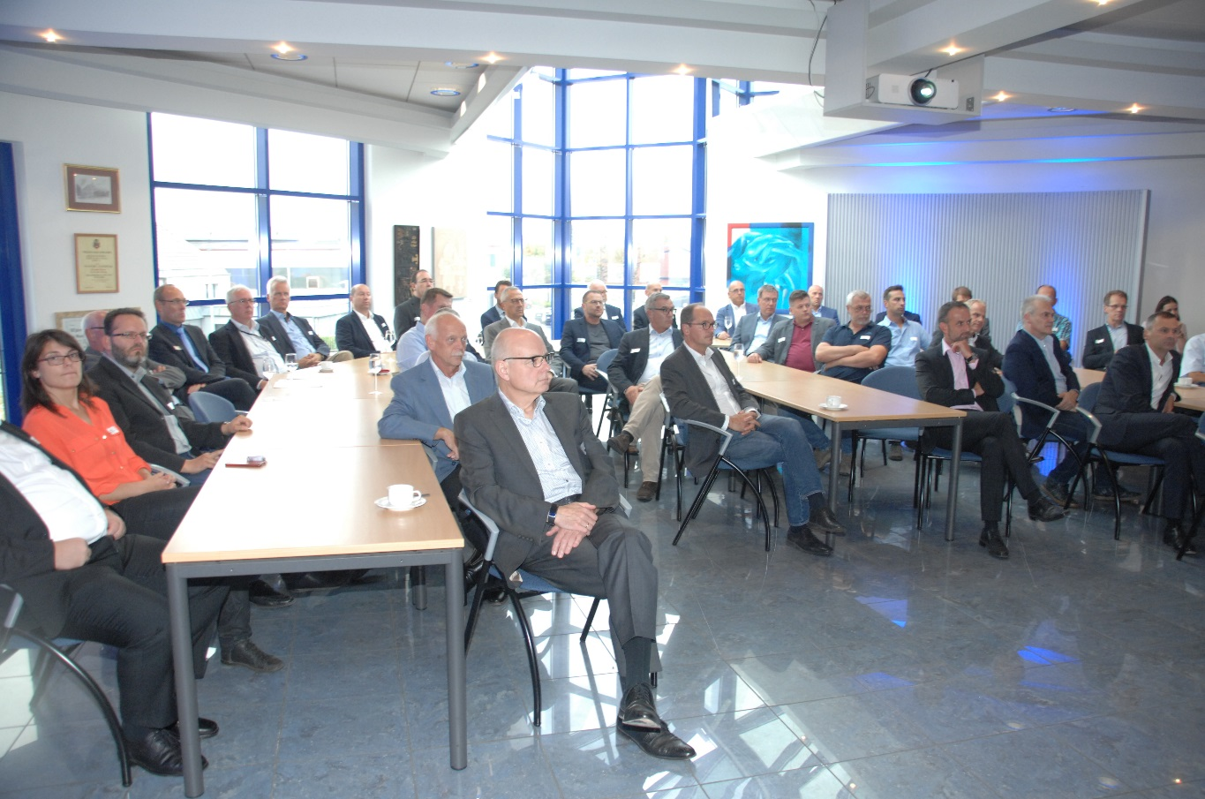
As a prelude to the IFRA in Berlin next month, Muller Martini invited customers to an open house at the Oppermann printing center in the northern German city of Rodenberg (Lower Saxony). Following an interesting presentation on the trends in the regional newspaper market, the 40 visitors saw the live production of several weekly and daily newspapers in the world’s most modern mailroom.

“We were fortunate to be able to welcome so many managing directors and technical supervisors from the German newspaper and publishing industry,” says Bernd Sauter, Managing Director of Muller Martini Germany, summing up the successful event in Rodenberg. The many decision-makers from large and small German newspaper publishers were very interested in the presentation by Christoph Rüth titled “Trends and Developments on the Regional Newspaper Market – Structural Change as an Opportunity.” Following the interesting remarks by the CEO of the Madsack Media Group, which produces its newspapers at Oppermann, the visitors to the open house had an opportunity to watch the production of a weekly newspaper with a number of inserts. Three hours later, they also saw the live production of the daily newspapers. In between, they took the opportunity, while enjoying a snack, to talk shop with the Muller Martini mailroom experts and to share experiences with their colleagues.
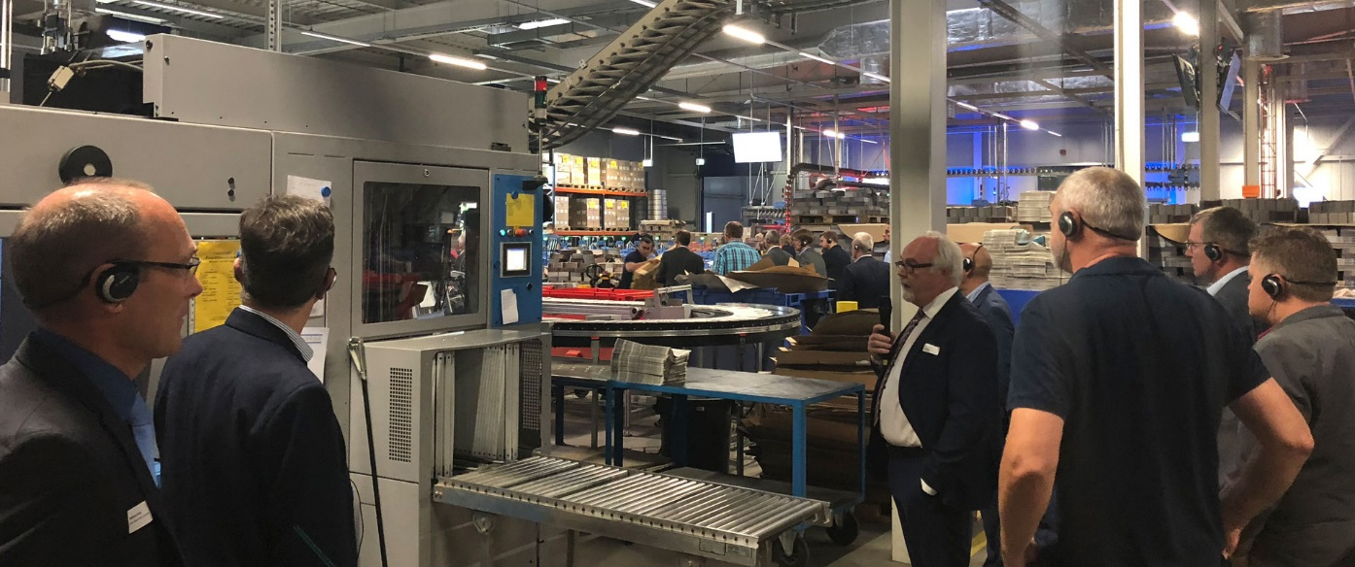
The live production in the most modern mailroom in the world met with great interest on the part of the visitors to the open house.

“As a prelude to the IFRA, it was a successful event,” says Bernd Sauter, referring to the open house. “Our guests were clearly impressed by the modern technology of the Muller Martini inserting systems and how Oppermann uses these systems on a daily basis.” At its facility in Rodenberg, Oppermann produces, in addition to three daily newspapers, more than 80 weekly newspapersfor both its own publishing company and for third-party customers, inserting more than 1.25 billion supplements on three Muller Martini ProLiner systems annually. They are loaded from a FlexiRoll buffer and controlled by the Connex.Mailroom controlling system for optimal production monitoring.

IFRA in Berlin: Muller Martini Showcases Its Finishing 4.0 Solutions in the Mailroom

For those who missed the open house at Oppermann, Muller Martini will be presenting its efficient and forward-looking newspaper inserting solutions at the IFRA World Publishing Expo & Digital Content Expo at Berlin’s ExpoCenter City from October 9 to 11. The company will be at booth F.10 in Hall 21a, showing how large numbers of inserts can be processed efficiently, even in smaller zones.
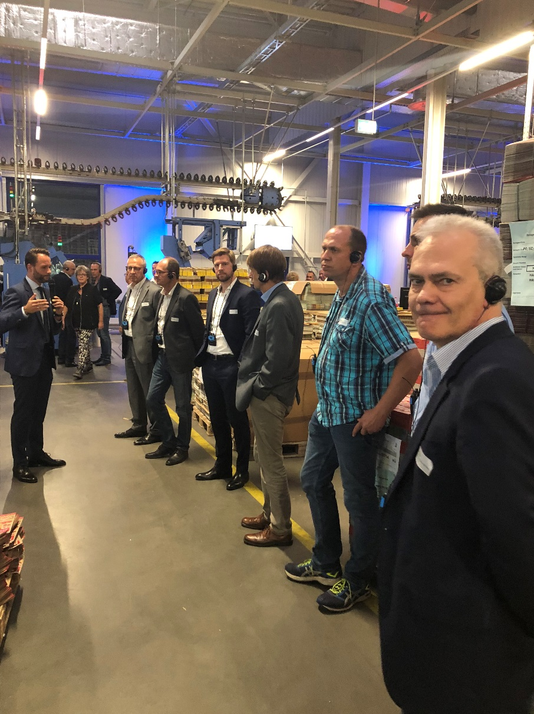
As “your strong partner,” the mailroom experts at Muller Martini will explain how you can strengthen your position in the insert market with the help of an optimized workflow in line with the Finishing 4.0 philosophy. Thanks to intelligent networking with the help of Connex 4.0 and the innovative inserting system, the rising volume of inserts can be produced efficiently and effectively, even in small zones. Visitors to the booth will be able to see for themselves how the high-performance feeders from Muller Martini can be used to seamlessly print a wide variety of inserts. In addition, visitors can use a virtual reality animation program to take a look inside the Oppermann mailroom.

The successful life-cycle management of the machines, as provided by Muller Martini's ^{MM}Services, will also be discussed at the booth. It ensures the long-term cost effectiveness of the systems, optimizes operating costs and extends the lifetime of the equipment by means of manageable investments.

