Medien-Information

Datum: 26.09.2017
Nr. PI 2118
Anzahl Zeichen 3361
Kontakt Müller Martini AG
Untere Brühlstrasse 13, CH-4800 Zofingen/Schweiz
Telefon +41 62 745 45 75, Fax +41 62 751 55 50
info@mullermartini.com, www.mullermartini.com

Open house at Frey Plus: lower costs and healthy sleep thanks to "Hilde" and "Hektor"

At the open house event at FREY PLUS in Ulm, the Frey agency and Muller Martini impressed the audience with the benefits of the MailLiner direct marketing system including FlexPack.

The brochure sorting machine with 28 feeders and the bundle building system take care of picking the unaddressed advertising and thus of the work mail carriers have to perform manually. At the gathering line of the MailLiner, one of the inserts is used as a cover and folded using an air blade – a Muller Martini innovation. The gathered insert sets then enter the FlexPack. Since there was a risk of bottlenecks at peak times, the Frey agency invested in a second machine. Giving "Hilde" a partner in the form of "Hektor", as the employees call their MailLiners, creates additional redundancy in the production system, a major benefit with the huge time pressure in this business, “which allows me to sleep far more peacefully”, says Managing Director Markus Springer.

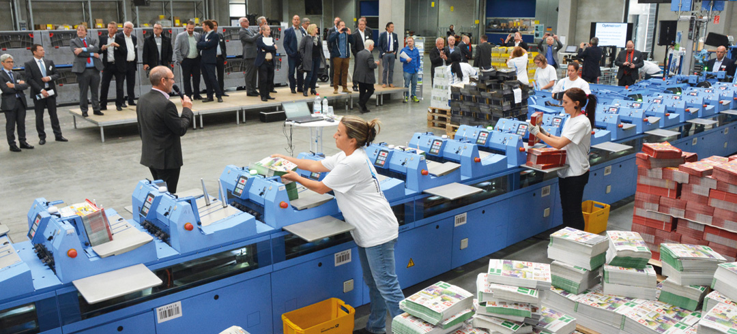The two "Hilde" and "Hektor" MailLiners attracted great attention at the open house event at Frey Plus.

Thanks to additional information provided by the Muller Martini specialists after the live demonstration, a comprehensive picture underlining the stable process was presented at the open house event. One Muller Martini customer, the technical director of a business with two ProLiners and twelve feeders each and mostly using newspapers as carriers of inserts, summed up the demonstration: “The system certainly proves that inserts can be picked without the involvement of newspaper delivery personnel.”

At Markus Springer’s presentation, one aspect in particular made the visitors to the open house event sit up and take notice: Because the Muller Martini solution enables his Frey agency to save several hundred thousand euros a year, the investment is recouped after less than three years. Springer emphasizes that, “Muller Martini was not the cheapest solution. But the collaboration has been excellent and we are continually working together to optimize planning and processes. We chose precisely the right partner at the time.”

Roman Bückle, who experienced how everything went at first hand as Head of Logistics, takes the same line. “I’m very calm and relaxed now. The heads of production are so well in control of things that we are improving every week.” For Bückle, the entire process was akin to a master stroke, which he had to deliver. The mere fact that “field tests” had to be conducted initially in rented premises constituted a logistical challenge. Since the new hall, which was specially erected, has been equipped and brought on stream, routes have become shorter and processes are running smoothly.

Markus Springer is convinced: “Within five years, households will be able to choose what brochures they want delivered at a click of the mouse button. By investing in the MailLiner, we are prepared for the future.” Finally, he called on his industry colleagues not to miss the opportunity and also gave a recommendation, “Muller Martini will bring you forward.”

Bernd Sauter, Managing Director of Muller Martini Germany, was delighted to accept the bouquet of flowers and passed on his message to the sector that, “the MailLiner is a highly efficient solution for direct marketing without a carrier.”

