Press Release

Date 20.06.2018
No. PI 2149
Number of characters 1961
Contact Muller Martini AG
Untere Brühlstrasse 13, CH-4800 Zofingen/Switzerland
Tel. +41 (0)62 745 45 75, Fax +41 (0)62 751 55 50
info@mullermartini.com, www.mullermartini.com

A Combo with Greater Efficiency

With the Tempo 220 saddle stitcher and the Integro inserting system, Oberdorfer Druckerei, located near Salzburg, has brought its industrial print finishing capabilities up to date.

The Austrian company, which is part of the CirclePrinters Central Europe Group, used the investment of around EUR 3 million in saddle stitching to align its entire workflow with current requirements in the production of catalogs, brochure and magazines. The Tempo 220 saddle stitcher, which delivers an ultra-high performance of 22,000 cycles per hour, and the Integro inserting system from Muller Martini perform saddle stitching and inserting functions at the same time. The new system also features a rotary saddle stitching system, which is designed for the production of standard products in high-volume runs.

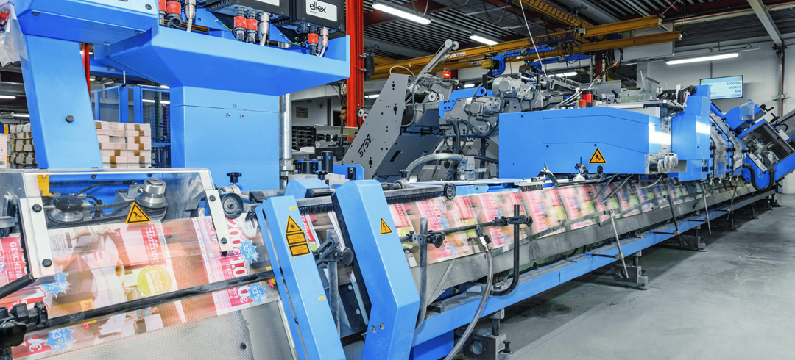By combining the various processes, Oberndorfer Druckerei has reduced the processing time per job by around 25 percent with the new Tempo 220.

“Customer expectations from service providers like us to provide a high degree of flexibility, rapid availability and customization are increasingly critical in print finishing,” says Managing Director Joachim Kühn. Thanks to the consolidation of the various processes, including labeling, film wrapping, shrink wrapping and palletizing, the processing time at Oberndorfer Druckerei has fallen by 25% per order.

Catalogs and magazines are also experiencing a renaissance in the Salzburg region, albeit with a different look. Customers increasingly want add-ons, such as cards and inserts, which are appealing for advertisers because they help to tailor products for regional markets. In six months, the Tempo 220 has already performed 30 million stitching processes, and particularly for small- and medium-sized runs, it is already in full swing with such add-ons, which represent additional value for the printing house, thanks to the short changeover times.

