Press Release

Date 07/03/2018
No. PI 2147
Number of characters 1072
Contact Müller Martini AG
Untere Brühlstrasse 13, CH-4800 Zofingen/Switzerland
Tel. +41 (0)62 745 45 75, Fax +41 (0)62 751 55 50
info@mullermartini.com, www.mullermartini.com

Printech Lends Impetus to the Russian Market

At Printech in Moscow, Muller Martini showcased exciting machine solutions, including for the digital market, at its extremely well-attended booth.

At Printech, Russia’s leading trade fair for the printing industry, between June 26 and 29 the country’s large and medium-sized printing plants and book manufacturers learned more about current machine solutions at Muller Martini’s booth. The visitors showed particular interest in print finishing solutions for digital printing in runs of right down to one copy, which are gaining ground in Russia too.
“We’re delighted with the visitor numbers”, says Roland Henn, Managing Director of Muller Martini Eastern Europe, confirming the success of the trade fair for Muller Martini. “We were especially pleased by the many interesting discussions with customers who are using Kolbus equipment.” In addition to specific negotiations about current projects, numerous agreements for further partnership with Muller Martini in the fields of spare parts and services were also concluded.

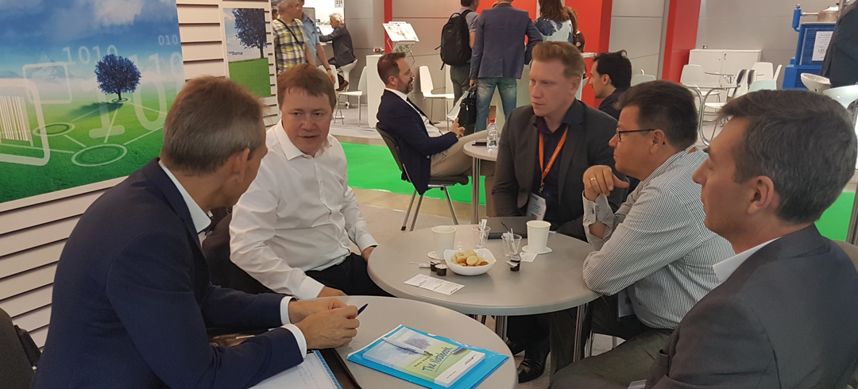
Muller Martini showcased current machine solutions at Printech in Moscow at its well-attended booth.

