Press Release

Date 26.09.2019
No. PI 2215
Number of characters 2161
Contact Muller Martini AG
Untere Brühlstrasse 17, CH-4800 Zofingen/Switzerland
Tel. +41 (0)62 745 45 75, Fax +41 (0)62 751 55 50
info@mullermartini.com, www.mullermartini.com

The Alegro Spreads Cheer

Bookbindery EFFEPI S.r.l. in Busto Garolfo, near Milan, needs half an hour less for the make-ready of a softcover job change. This substantial time saving has been made possible by a new Alegro perfect binder from Muller Martini.

In classical music, “allegro” is usually a prompt for playing music cheerfully and quickly. The Alegro now conveys a similar sentiment at EFFEPI. With an average of six job changes per day, changeovers are now much quicker, enabling an additional two orders to be produced during the three hours that have been gained. Cutting the cord on a 15-year-old perfect binder and the resulting efficiency improvement – not least thanks to the use of the Book Data Center (BDC) – has spread a lot of cheer at the family company, which can once again react more flexibly to the market situation.

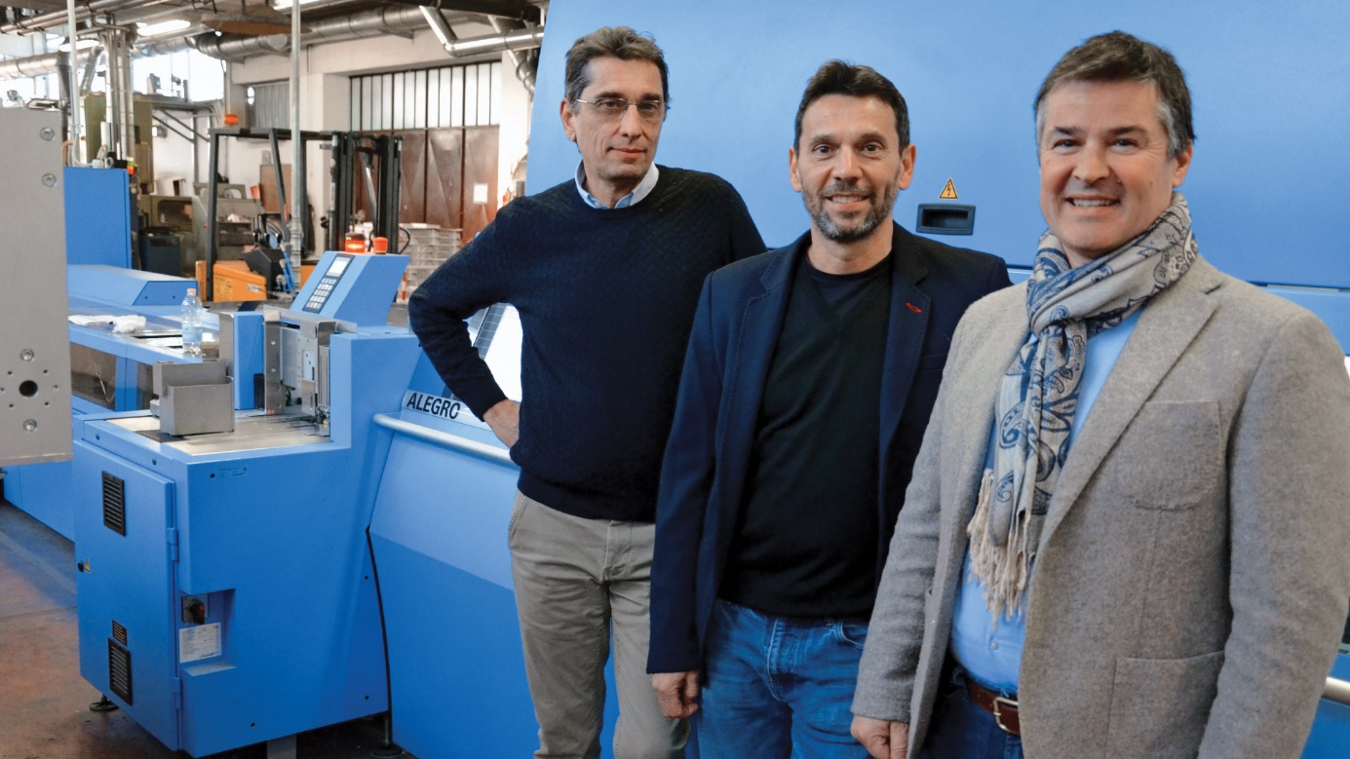

Company owners Ruggero and Luca Porta with Fabio Casale (Sales Manager at Muller Martini Italy) in front of the Alegro perfect new binder at EFFEPI.

The Alegro, with a 15-station gathering machine, book block feeder and Solit three-knife trimmer, thanks to the modular design of Muller Martini machines, is another major advantage. “Thanks to the modularity, we can expand the line at any time,” says Ruggero Porta, who is responsible for the company’s administrative affairs. This is because the company, which has 35 employees, will continue to require flexibility in the future in order to meet the needs of all its customers. EFFEPI currently produces books (softcover, hardcover and thread sewing) as well as high-quality fashion catalogs with runs of between 500 and 100,000 copies.

Following the installation of a Muller Martini Trendbinder in 2002, the north Italian bookbindery is the first in the country to offer its customers PUR. It does so working on the Alegro. However, if the Trendbinder is removed from the network, retrofitting with two-shot cold emulsion is a snap. “Because of its good layflat behavior, we still see high demand from our customers for two-shot cold emulsion,” notes Production Manager Luca Porta. “As a result, the Alegro has also been prepared for this gluing process.”

