Press Release

Date 03.09.2019
No. PI 2213
Number of characters 1979
Contact Muller Martini AG
Untere Brühlstrasse 17, CH-4800 Zofingen/Switzerland
Tel. +41 (0)62 745 45 75, Fax +41 (0)62 751 55 50
info@mullermartini.com, www.mullermartini.com

Reliure Service Once Again Adjusts to Market Requirements

With its new Alegro A7, the fourth perfect binder from Muller Martini in the company’s 50-year history, Reliure Service S.A. in Meyrin, located in the Swiss canton of Geneva, is aiming for various new market segments.

Swiss brochure, Ota binding, books with liners, large sizes – starting this January, Reliure Service will be expanding its product range to include these services for its customers, mainly in French-speaking Switzerland, but also increasingly for customers in German-speaking Switzerland as well. For this reason, the last independent industrial bookbindery in the French-speaking part of western Switzerland is replacing its 13-year-old Acoro A7 with a new Alegro A7 perfect binder with an 18-station 3694 gathering machine.
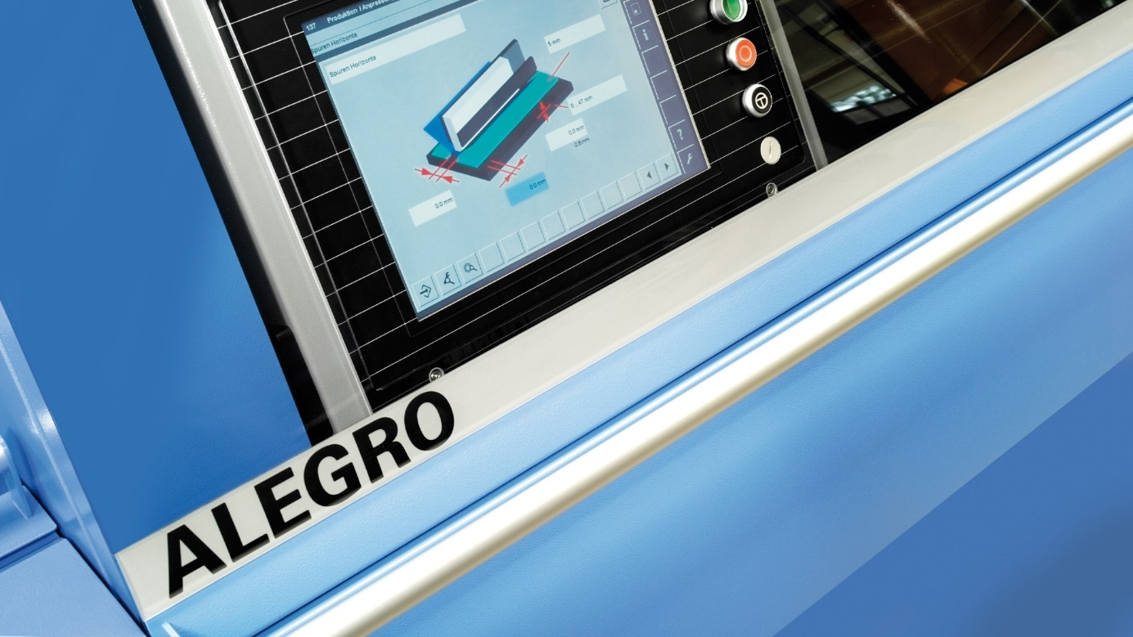
Together with a Pony, Monostar and Acoro A7, the Alegro is the fourth perfect binder from Muller Martini in the 50-year history of Reliure S.A.

Stéphane Stauffer (Director of Technology) and his brother Didier (Director of Administration) head the family company, which was founded by their father Jacques exactly 50 years ago. For the two proven graphic arts industry experts, there was never a doubt “that we wanted to continue the successful partnership with Muller Martini and add an Alegro A7 to the three perfect binders – a Pony, Monostar and Acoro A7 – we already had.”

With its new perfect binder, Reliure Service, which has three other Muller Martini systems – a BravoPlus Amrys saddle stitcher, an Inventa II thread sewing machine and a Solo-ZTM 210 S – is now able to accommodate smaller print runs as well. The Meyrin-based company does occasionally produce long-run jobs with as many as 500,000 copies. However, the average run is between 1,500 and 2,000 copies – and the Alegro’s individual drives, reproducible job data integration capability in a workflow system ensure extremely short processing times and thus unbeatable production costs for books and brochures.

