Press Release

Date: 20.09.2017
No. PI 2117
Number of characters 1917
Contact Muller Martini AG
Untere Brühlstrasse 13, CH-4800 Zofingen/Switzerland
Tel. +41 (0)62 745 45 75, Fax +41 (0)62 751 55 50
info@mullermartini.com, www.mullermartini.com

Print 17 in Chicago – Muller Martini Impresses
Visitors with its Finishing 4.0 Solutions

The touchless workflow solutions that were presented live at the Muller Martini booth at Print 17 in Chicago under the slogan of “Finishing 4.0” met with great interest among the many visitors.

During the five-day trade fair, Muller Martini showcased no fewer than three systems of the latest digital generation that are designed for variable and customized print products in short and ultra-short runs – the Presto II Digital saddle stitcher, the Vareo perfect binder and the InfiniTrim three-knife trimmer. The large interest shown in the Muller Martini booth proved that Muller Martini has its finger on the pulse of the graphic arts industry.

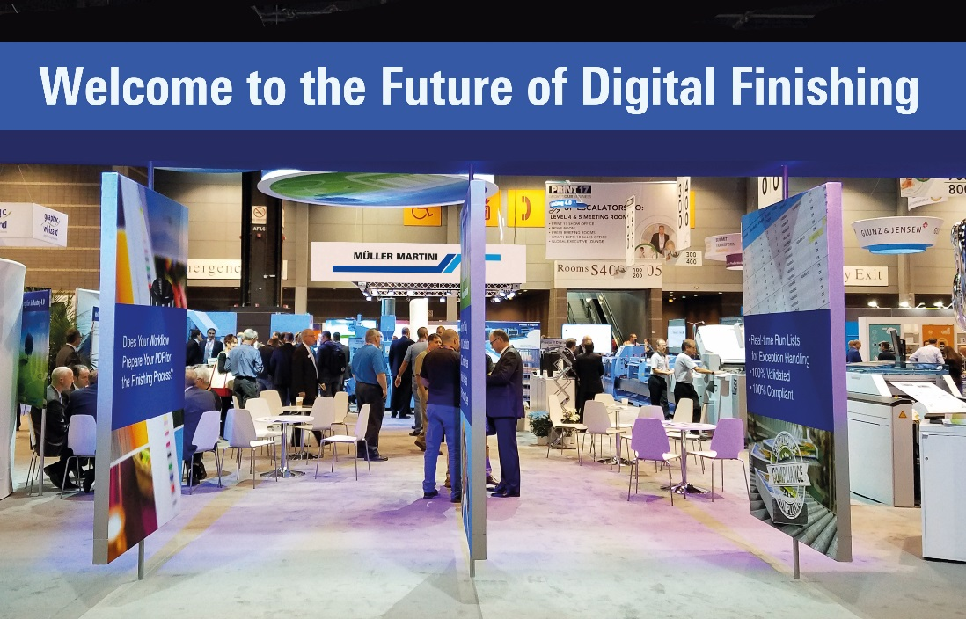
The Muller Martini booth proved very popular on all five days of the trade fair.

A live demonstration at the Presto II Digital showed how offset and digitally printed signatures can be stitched to form a range of hybrid print products. Using the Vareo and InfiniTrim, several softcover products with diverse sizes and thicknesses were likewise produced live. Visitors were particularly impressed by the revolutionary unit drive technology for all grippers and knives of the InfiniTrim, which ensures the optimal pressing and correct positioning of every single product.

In addition to the machine demos, the many customers – including numerous representatives of major North American printing plants, who wanted to find out more about Muller Martini’s latest digital solutions in Chicago – took great interest in the multimedia presentation of Connex. To the delight of Werner Naegeli, CEO of Muller Martini North America, the data and process management system that enables the optimal automation of all Muller Martini systems, from standalone machines to complex production lines, won a “Must See 'Ems Award” in the “Postpress and Inline Finishing” category at Print 17.

