Press Release

Date 10.11.2017
No. PI 2112
Number of characters 1923
Contact Muller Martini AG
Untere Brühlstrasse 13, CH-4800 Zofingen/Switzerland
Tel. +41 (0)62 745 45 75, Fax +41 (0)62 751 55 50
info@mullermartini.com, www.mullermartini.com

As Swiss as it Gets

A bold investment in a Pantera perfect binder is paving the way for the Swiss bookbindery called Schweizer Buchbinderei to act as a softcover partner to big-name printing plants.

After acquiring the business, which today employs five people, in Egg near Zürich six years ago, the 28-year-old Morgane Schweizer has continually adapted it to customer needs. Since a one-clamp perfect binder was proving insufficient for handling increasingly long runs, she took the plunge and invested in a Pantera that is designed for PUR binding and is equipped with a 12-station gathering machine and a Granit three-knife trimmer. The positive feedback she has received about the high production quality of the new perfect binder confirms that she is on the right track.

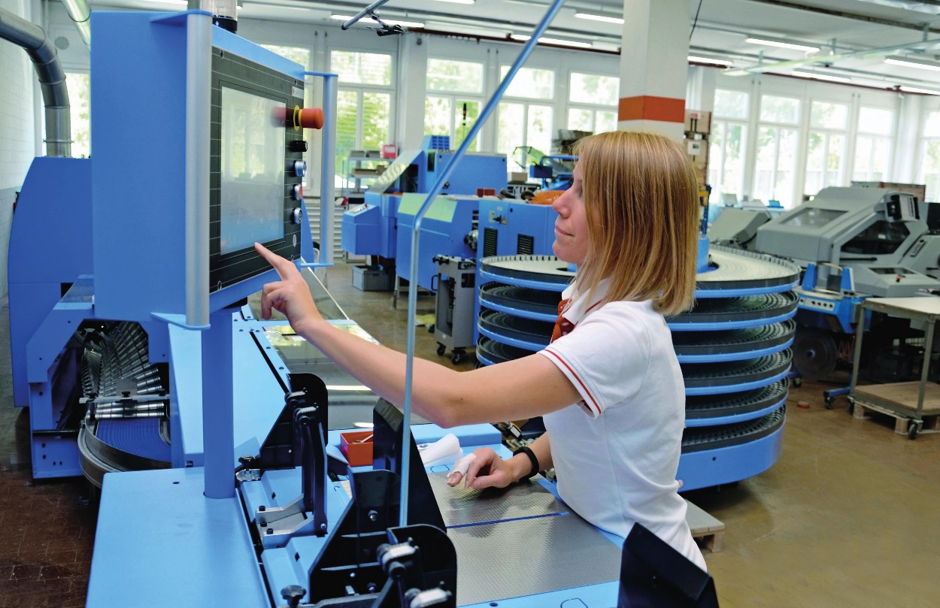Company head Morgane Schweizer operates the new Pantera perfect binder herself.

The Schweizer bookbindery aims to establish a more dense network of partners on the Swiss market. “I’ve noticed that Swiss printing plants are increasingly having their print products produced in Switzerland again due to the short distances involved,” says the company owner. The Pantera enables her to produce not only folded leaflets, but also saddle-stitched and perfect-bound brochures in runs of 3,000 copies on average, with high flexibility and short turnaround times. In addition, it has led to the company securing further jobs, especially lamination.

The company head explains that there were several reasons why she chose the new Pantera perfect binder, which is designed for a wide size range: first, the convincing demo at Muller Martini’s Book Academy; second, the short changeover times; third, the easy operation; and, fourth, her personal conviction that “produced in Switzerland should apply across the board”. That is entirely in keeping with the name of the company (Schweizer), which, aside from being the surname of the company owner, means “Swiss”.

