Press Release

Date 06.07.2017
No. PI 2094
Number of characters 1820
Contact Muller Martini AG
Untere Brühlstrasse 13, 4800 Zofingen, Switzerland
Tel. +41 (0)62 745 45 75, Fax +41 (0)62 751 55 50
info@mullermartini.com, www.mullermartini.com

Solutions for Warehousing Problems

Printondemand, which delivers promptly worldwide in response to online orders, is making warehousing a thing of the past. The UK’s leading book-of-one producer uses the Vareo/InfiniTrim “dream team” for that purpose.

For the short-run specialist in the county of Cambridgeshire, even 100 copies per job counts as a long run. The new Vareo perfect binder and the InfiniTrim three-knife trimmer, which was commissioned in June, are proving indispensable for softcover production. The Vareo lends itself to short runs because each of its three clamps is individually driven by a servo motor. The revolutionary drive, conveying and trimming concept of the InfiniTrim ensures the optimal pressing and correct positioning of every single product.
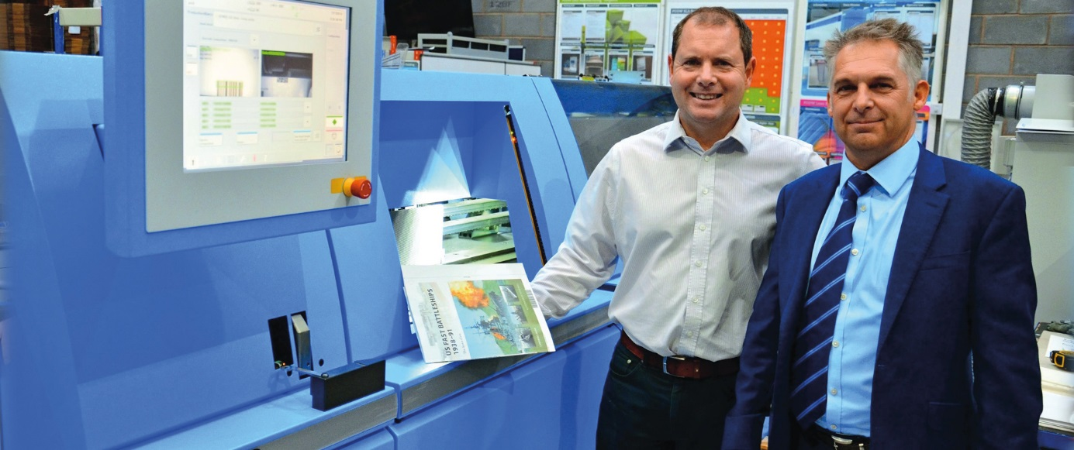

Managing Director Andy Cork (left) and Ian Clarke, Sales Manager at Muller Martini UK, believe the Vareo perfect binder is the ideal solution for short runs.

“A one-touch solution between binding and trimming is essential in short-run production,” says Printondemand founder Andy Cork, emphasizing the importance of efficient processes. For the English company, cost-effective thinking starts with the order process – publishing companies and self-publishers can place orders online themselves. The orders that have been entered are processed in an inline workflow, involving several highly automated systems, from the digital printing press to the three-knife trimmer.

The company’s proprietary web-based software enables print-on demand customers to place their orders online in the print order system. They can store titles, with wide-ranging content and formats, in the BookVault, and retrieve the data at any time. Standard jobs are dispatched within 24 to 48 hours. More complex jobs with special covers or film wrapping take slightly longer.

