Media Information

Date 05.06.2024

No. PI 2443

Number of characters 1759

Contact Müller Martini AG

Untere Brühlstrasse 17, 4800 Zofingen/Switzerland

Phone +41 62 745 45 45

info@mullermartini.com, www.mullermartini.com

**Perfect binder from Muller Martini**

Purchased Within a Week: Another Alegro for GV Group

**With more than 30 active Muller Martini systems, GV Group has been relying on hardcover and softcover systems from Muller Martini for a long time. At drupa, this close partnership continues with the signing of a contract for an Alegro perfect binder.**

GV Group, a global player in the book manufacturing business with print shops in Europe and North America, sets the bar high: books are delivered within 24 hours of being ordered. “To achieve this goal, our production facilities must have a high level of automation and availability,” explains Nicola Franceschi, CEO of GV Group. “With Muller Martini, we have a partner that we can rely on one hundred percent to make this happen.”

As the group already has an [Alegro](https://www.mullermartini.com/en/products-en/softcover-production/perfect-binding/alegro/) in operation and has had good experiences with it, the decision to purchase another perfect binder, which will be installed at their Lake Book facility in Illinois in the USA, was made within just one week. “With two or three-shift production, we benefit not only from the reliability but also from the flexibility and versatility of this perfect binder,” adds Nicola Franceschi. “That's why it quickly became clear that we needed another Alegro.”

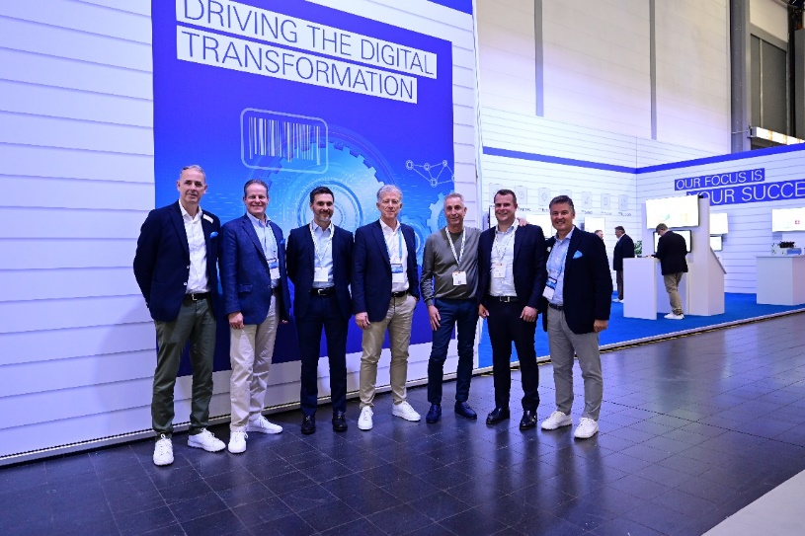

*Gv Group opted for another Alegro perfect binder within a week. Signing the contract at the Muller Martini drupa booth: Fabio Franceschi, President (third from right), his son Nicola Franceschi, CEO (second from right) and Giorgio Bertan, Member of the Board (third from left) all from GV Group, as well as (from left) Bernd Volken, President Region Western Europe, Andy Fetherman, President and CEO Region North America, Bruno Müller, CEO and Fabio Casale, Sales Manager Western Europe (all Muller Martini).*