Media Information

Datum 10.08.2022
Nr. PI 2348
Anzahl Zeichen 2979
Kontakt Müller Martini AG
Untere Brühlstrasse 17, 4800 Zofingen/Schweiz
Telefon +41 62 745 45 45
info@mullermartini.com, www.mullermartini.com

Making one out of two

To replace an aging Prima S, D+L Printpartner in Bocholt, Germany, which specializes in the production of magazines and operating manuals, invested in a Primera PRO, another saddle stitcher from Muller Martini.

Thomas Klein-Bösing had already had his sights set on the Primera PRO. However, the managing director, who has been with D+L Printpartner for 35 years, was finally impressed when he saw the 14,000-cycle saddle stitcher from Muller Martini in action in the showroom of the Heidelberg Print Media Center in Wiesloch, Germany. This is because Muller Martini offers its customers presentations there on a Primera PRO with cover feeder, four flat pile feeders and two vertical feeders, SEMKO, 0504 three-knife trimmer with center cut, Perfetto compensating stacker with Amrys and air table. "And this demo really convinced me," says Thomas Klein-Bösing, who had actually "only" wanted to look at the presses at Heidelberg Technology Day.

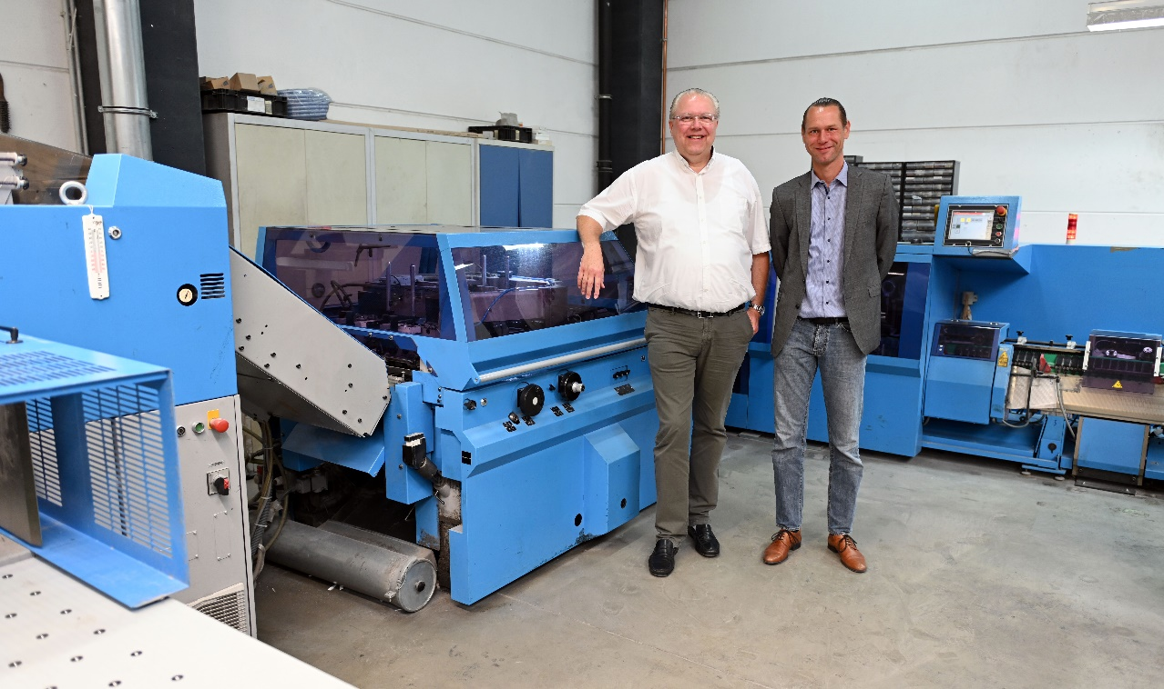
Thomas Klein-Bösing (left/in front of the Primera C130 saddle stitcher): "For us as a magazine specialist, high machine availability is particularly important." On the right, the second Managing Director of D+L Printpartner, Dirk Reichenberg.

He was particularly impressed by the fast format changeover from A4 to A5. "In just three minutes, the Primera PRO was changed over." Saddle stitching has traditionally been a high – and recently rising – priority at the full-service family business, which employs 87 people and accounts for 60 percent of production volume. This is because D+L Printpartner, which was one of the first German companies to enter digital printing after drupa 1995, specializes in the production of (also perfect-bound) magazines.

Around 140 periodicals – ranging from weekly, fortnightly and monthly to ten times a year – are printed and processed in Bocholt for customers throughout Germany with print runs of between 1,000 and 50,000 copies. In addition to commercial work of all kinds, operating manuals in various languages are a second important mainstay.

"Not only is fast make-ready important for us, but also high machine availability, especially for the magazines that are scheduled exactly on one publication day and have an increasingly narrow production time window," emphasizes Thomas Klein-Bösing. In order to be able to deliver the time-sensitive periodicals at any time without delay, D+L Printpartner has been using two saddle stitchers from Muller Martini for many years – a PrimaPlus for over two decades and, since 2008, a Primera C130 as the first graphic arts company in the world.

The retiring Prima S will be replaced at the end of this year by the Primera PRO with turnover feeder, seven flat pile feeder and Perfetto compensating stacker. The plan is for it to take over the entire saddle stitching range from D+L Printpartner – in keeping with the motto "two make one". "The Primera C130 will then take on the important role of backup machine," says Thomas Klein-Bösing.

