Media information

Date 5.6.2024

No. PI 2456

Number of characters 1'332

Contact Müller Martini AG

Untere Brühlstrasse 17, CH-4800 Zofingen/Switzerland

Phone +41 62 745 45 45

info@mullermartini.com, www.mullermartini.com

**D.O.G. GmbH at drupa 2024**

**Long-standing Partnership – This Time the Prinova was Paired with a Golden Pen**

**When Johann Gass signed the contract for a new** [**Prinova saddle stitcher**](https://www.mullermartini.com/en/products-en/stitching-systems/saddle-stitching/prinova/) **at Muller Martini's drupa booth, he pulled out his silver ballpoint pen. He had received it as a gift from Frank Skorna, Sales Manager at Muller Martini Germany, when he purchased a Bravo Plus saddle stitcher 17 years ago.**

The long-standing partnership between the managing director of D.O.G. GmbH in Darmstadt, Germany, and Muller Martini has now culminated in the signing of a contract for a new saddle stitcher. It will be used to handle the increased order volume in recent years in the demanding packaging requirements of the pharmaceutical and cosmetics industry, in which the company specializes.

“We know the reliability of the Muller Martini brand and will continue to rely on it”, comments Johann Gass on the deal. Both he and his son André Gass were particularly pleased to receive a golden pen from Frank Skorna this time.

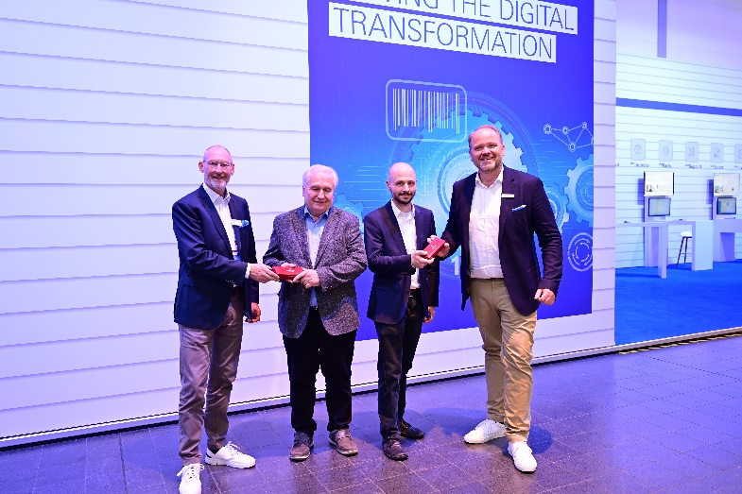

*Signing the contract for a Prinova saddle stitcher at the Muller Martini drupa booth: Johann Gass (second from left) and André Gass (second from right), both managing directors of D.O.G. GmbH, together with Frank Skorna, sales manager at Muller Martini (left), and Bernd Gosewehr, managing director at Muller Martini Rahden.*