Media information

Date 31.01.2024
No. PI 2415
Number of characters 2594
Contact Müller Martini AG
Untere Brühlstrasse 17, CH-4800 Zofingen/Switzerland
Phone +41 62 745 45 45
info@mullermartini.com, www.mullermartini.com

Muller Martini and Shandong Xinhua Printing

Large Number of Visitors at the Muller Martini Open House in China

More than 120 people were impressed by the Publica PRO 15 perfect binder at an open house organized by Muller Martini in mid-January in collaboration with its customer Shandong Xinhua Printing.

"We had actually planned a small-scale open house," explains Sven Olsen, Regional Director Muller Martini Asia Pacific. "But to our great delight, the announcement triggered a veritable rush of visitors." In the end, Muller Martini and the Shandong Xinhua Printing welcomed more than 120 visitors to the joint open house at the Jinan site. One of their two new Muller Martini Publica PRO 15 perfect binders was presented live by Shandong Xinhua Printing.

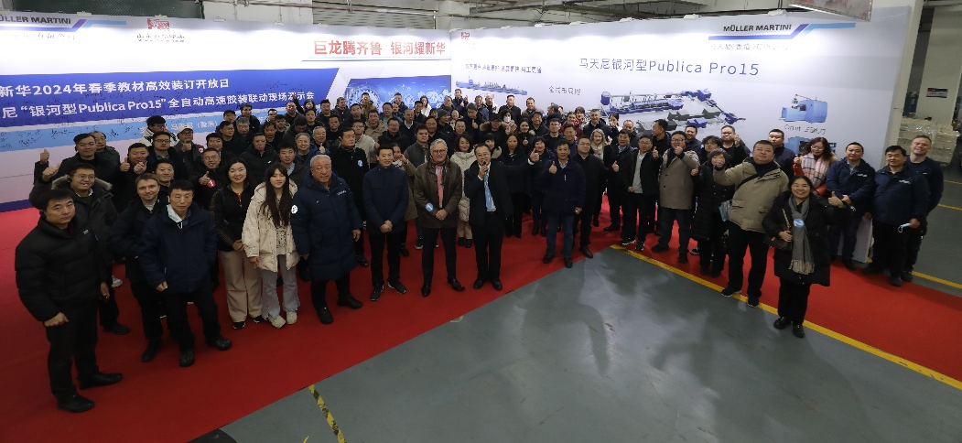
Visitors to the Open House, which Muller Martini organized together with its customer Shandong Xinhua Printing at the Jinan site, showed great interest in the Publica PRO 15 perfect binder.

The highly automated Publica PRO 15 line includes stream feeders, several end-of-line packaging alternatives, a Pluton palletizer from Solema and is equipped with the Connex workflow system. During the demonstration, the line was running at a speed of 14,000 copies/hour and was manned by just five people. "The demonstration was a real eye-opener for the customers present, who consisted of over 40 of China's largest government printing companies, including their top management," says Sven Olsen, emphasizing the enthusiasm of the visitors.

During the subsequent presentation, the extremely detailed equipment selection process and high requirements of Shandong Xinhua were emphasized. The reasons for investing in the Publica PRO 15 were not only the high production speed, the first-class quality of the end products and the high level of efficiency, but also the reduced need for manpower. This is because the Publica PRO 15 is operated at Shandong Xinhua Printing with 50 percent fewer personnel than previous models. As a result, Shandong Xinhua Printing - which operates three factories in Shandong Province (Jinan, Dezhou and Tai'an) and, in addition to the two Publica PRO 15s, also have two Diamant/Collibri hardcover lines, a Ventura Connect system, a Bolero perfect binder and a number of older Muller Martini systems - has positioned themself at the forefront of printing factories in China.

