Media information

Date 18.09.2024

No. PI 2465

No. of characters 3716

Contact Müller Martini AG

Untere Brühlstrasse 17, 4800 Zofingen/Switzerland

Phone +41 62 745 45 45

info@mullermartini.com, www.mullermartini.com

Driving the Digital Transformation

**PRINTING United Expo 2024: North American Premiere Impressed Many Visitors**

**The PRINTING United Expo 2024, which took place from September 10 to 12 in Las Vegas, was a big success for Muller Martini. The biggest draw at the booth was the new [Hunkeler Starbook Sheetfolder](https://www.hunkeler.ch/en/solutions/starbook-sheetfolder-book-solution-inline/), which was presented as a North American premiere in-line with the [Vareo PRO](https://www.mullermartini.com/en/products-en/softcover-production/perfect-binding/vareo-pro/) perfect binder from Muller Martini.**

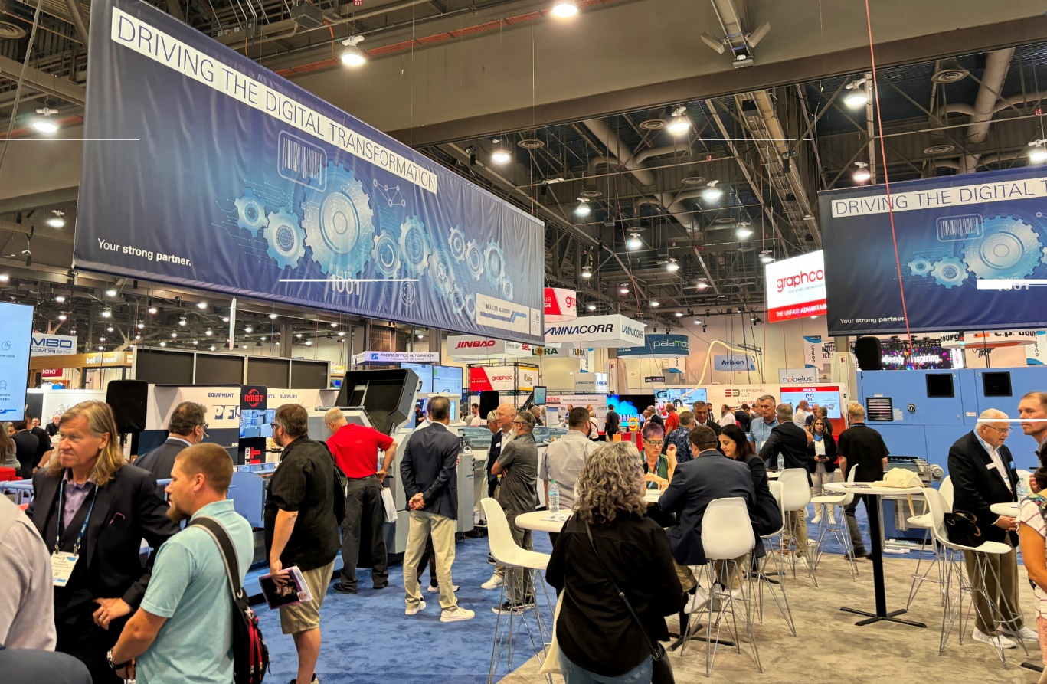

Muller Martini set new standards in the North American market for Smart Factoy solutions with the machines on display in their booth. "Our latest developments combine decades of know-how with state-of-the-art technology and enable unprecedented efficiency and precision in print finishing," said Andy Fetherman, President and CEO of Muller Martini Corp. in North America. "The positive response from visitors shows that we are on the right track to drive digital transformation in the printing industry."

The demonstrations of the new [Starbook Sheetfolder](https://www.hunkeler.ch/en/solutions/starbook-sheetfolder-book-solution-inline/) from Hunkeler were always very well attended at the Muller Martini stand. Andy Fetherman explains the visitors' fascination with the fully integrated configuration of the [Starbook Sheetfolder](https://www.hunkeler.ch/en/solutions/starbook-sheetfolder-book-solution-inline/)/[Vareo PRO line](https://www.mullermartini.com/en/products-en/softcover-production/perfect-binding/vareo-pro/): "Currently, there are many manual steps required to produce a book in a cut sheet workflow, which are essentially eliminated with this groundbreaking solution."

**Smart Factory solutions**Visitors were also able to experience the Hunkeler roll-fed [Prinova Digital saddle stitcher](https://www.mullermartini.com/en/products-en/digital-solutions/digital-saddle-stitching-systems/prinova-digital/) and the [InfiniTrim](https://www.mullermartini.com/en/products-en/softcover-production/trimming/infinitrim/) robot trimmer first-hand. Both technologies take production processes to a new level and offer print shops the flexibility and efficiency they need in a dynamic market environment.

"Despite a lower number of visitors at times compared to previous events, the quality of the discussions was extremely high," said Andy Fetherman. "The machines and the entire Muller Martini team did their usual excellent job and we were able to hold many discussions with customers and prospects."

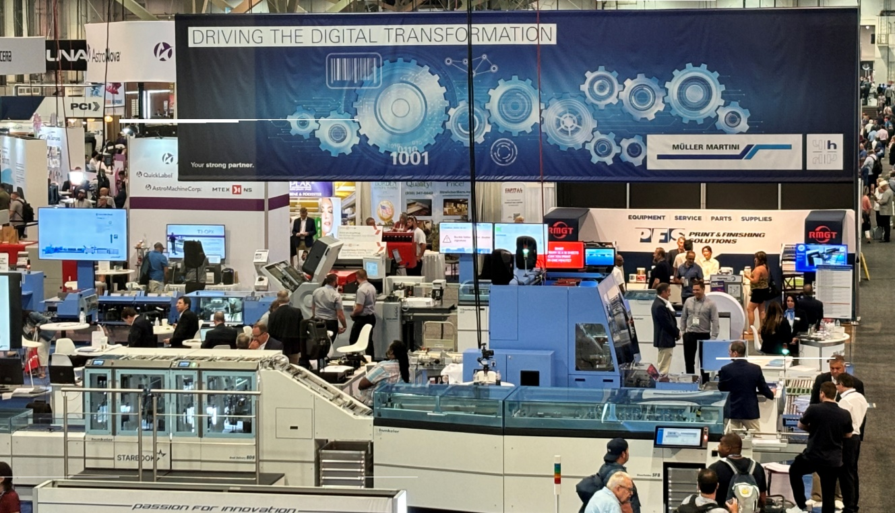*Premiere in North America: At the PRINTING United Expo, which took place from September 10 to 12, 2024 at the Las Vegas Convention Center, Muller Martini presented the new cutsheet digital solution consisting of the Starbook Sheetfolder from Hunkeler in-line with the Vareo PRO perfect binder from Muller Martini for the first time in North America. The Hunkeler roll-fed Prinova Digital saddle stitcher and the InfiniTrim robot trimmer were also on show live at the stand.*

**Connex Workflow System demo: The future of workflow optimization**The industry-leading [Connex Workflow System](https://www.mullermartini.com/en/products-en/workflow-systems/connex/connex-workflow-system/) from Muller Martini was also an important topic of conversation for visitors to PRINTING United Expo. Thanks to end-to-end data handling and synchronized output management, Connex significantly increases efficiency and reduces operating costs by providing a complete file to finished product workflow solution. The experts from Muller Martini demonstrated to trade fair visitors how Connex can transform their business processes and increase profitability.

Furthermore, the merger with Hunkeler was a much-discussed topic. Both trade fair visitors and media representatives wanted to know about the future support options for the Hunkeler portfolio in North America. Andy Fetherman: "We reviewed some of the details of our road map to ensure a smooth transition to all end users for Hunkeler technical sales support, spare parts availability, training and technical services going forward."

This year's PRINTING United Expo provided an excellent platform for customers and interested parties to find out about the latest technologies and trends in the finishing sector. "We are looking forward to working the various new opportunities that came out of this event," says Andy Fetherman.