Media Information

Date 8/26/2024
No. PI 2462
Number of characters 2323
Contact Müller Martini AG
Untere Brühlstrasse 17, 4800 Zofingen/Switzerland
Phone +41 62 745 45 45
info@mullermartini.com, www.mullermartini.com

Driving the digital transformation

Printing United Expo 2024: Finishing on a New Level

At the Printing United Expo, taking place from September 10 to 12, 2024, in Las Vegas, USA, Müller Martini will present its latest developments in the area of smart factory solutions. This includes the North American premiere of the new Hunkeler Starbook sheetfolder, which will be showcased together with the Vareo PRO perfect binder.

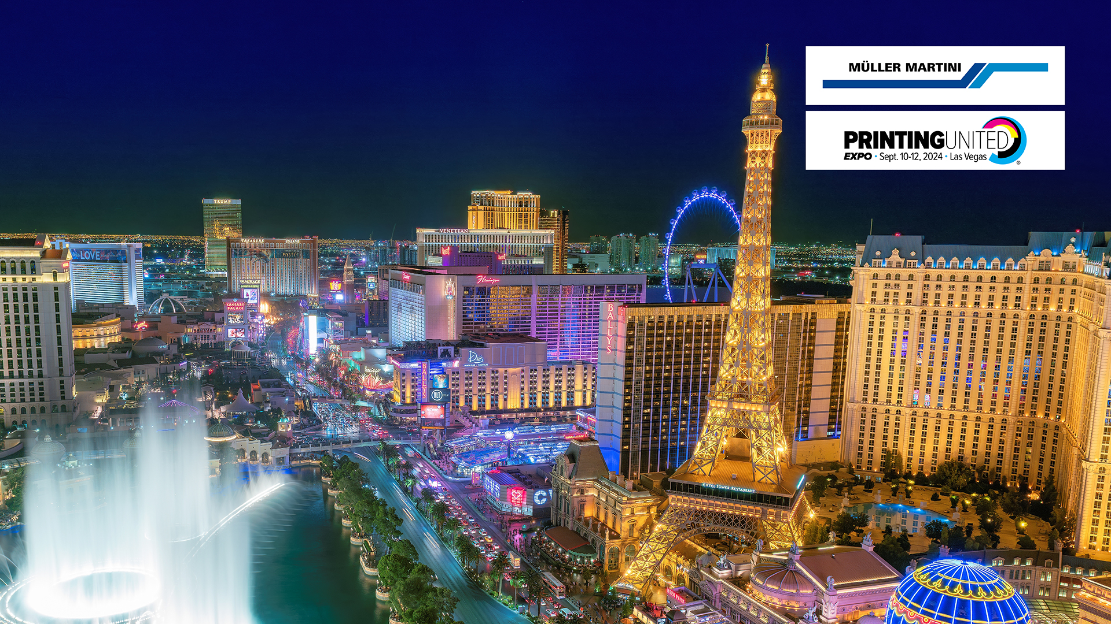

By combining decades of expertise with state-of-the-art technology, the innovations from Müller Martini guarantee an unparalleled level of efficiency and precision in print finishing. At the booth, visitors will experience first-hand how the Prinova Digital saddle stitcher and the digital binding solutions, including the InfiniTrim trimming robot, can be seamlessly integrated into the groundbreaking Connex workflow system, taking production processes to a whole new level.

Connex demo: The future of workflow optimization
The industry leading Connex workflow system from Muller Martini is crucial to the future of print finishing. From continuous data handling to synchronized output management, the market leading solution significantly increases efficiency, lowers operating costs and ensures the highest quality. Our experts will show visitors to the booth how Connex can revolutionize their workflows and boost profitability in a competition-oriented market environment.

A vital opportunity for EXPO visitors
We extend a warm invitation to customers and top prospects to secure their spot early for our exclusive presentations at booth C2561 at the Las Vegas Convention Center. There, you’ll learn more about the future of finishing first-hand and how the latest Müller Martini and Hunkeler technology is driving digital transformation in the graphic arts industry. Our experts are available for any questions you may have.

To sign up, reach out to your local contact.

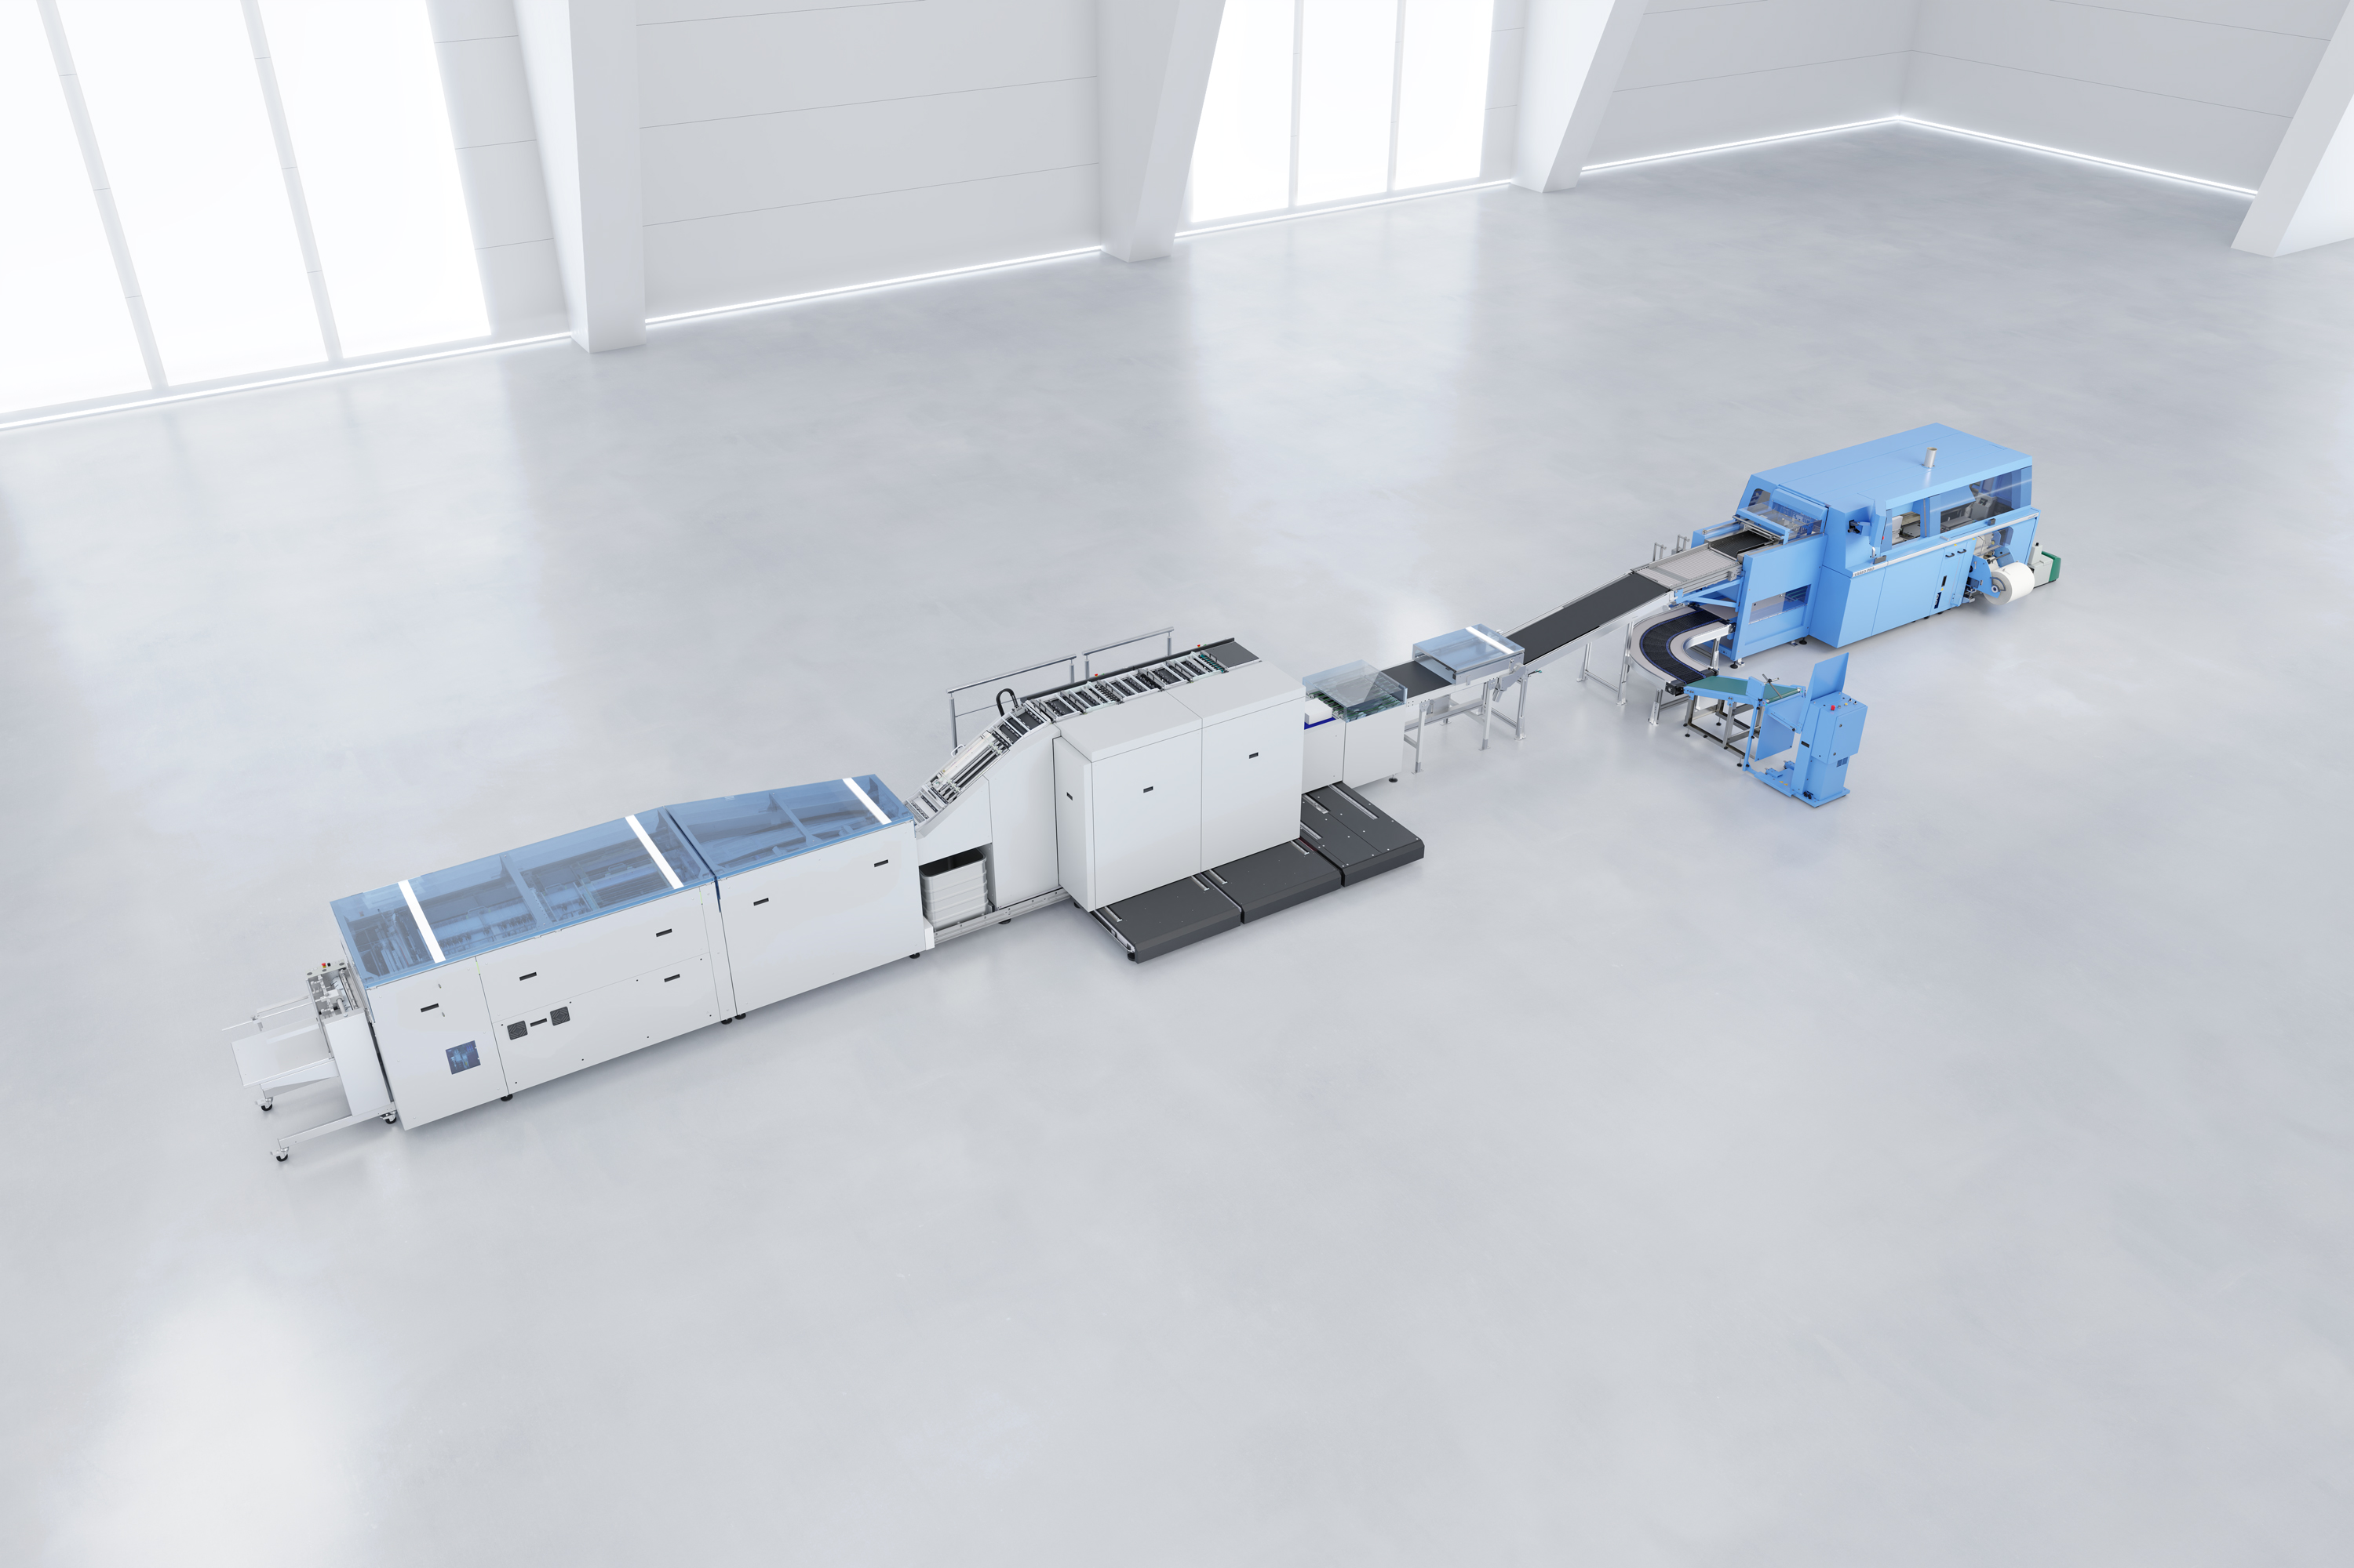
Premiere in North America: At the Printing United Expo, taking place from September 10 to 12, 2024, at the Las Vegas Convention Center, Müller Martini will for the first time ever present its new digital solution made up of the Starbook sheetfolder from Hunkeler and the Vareo PRO perfect binder from Müller Martini. The Prinova Digital saddle stitcher and the InfiniTrim trimming robot will also be showcased live at booth C2561.

