Media Information

Date 7/3/2024
No. PI 2459
Number of characters 1290
Contact Müller Martini AG
Untere Brühlstrasse 17, 4800 Zofingen/Switzerland
Phone +41 62 745 45 45
info@mullermartini.com, www.mullermartini.com

Social responsibility

Muller Martini Donates Coloring Books and Notebooks

Muller Martini is stepping up its social responsibility by supporting a social project at the Ayurveda Shunyata Villa in Sri Lanka.

The coloring books and notebooks produced at the Print Finishing Center in Zofingen have been donated to a kindergarten and a school. The aim of the campaign is to provide the children with school materials and thus support their education.

"We are delighted to be able to put the many products produced during demos and training sessions at our training center to good use," says Christoph Müller, Head of the Print Finishing Center. "With this initiative, we are not only bringing joy to the children, but are also taking responsibility against paper waste and for greater sustainability."

The saddle-stitched coloring books were produced on a Prinova Digital saddle stitcher, the perfect-bound notebooks on the Vareo PRO and the new Antaro Digital perfect binders. You can experience all the machines live at the Print Finishing Center in Zofingen.

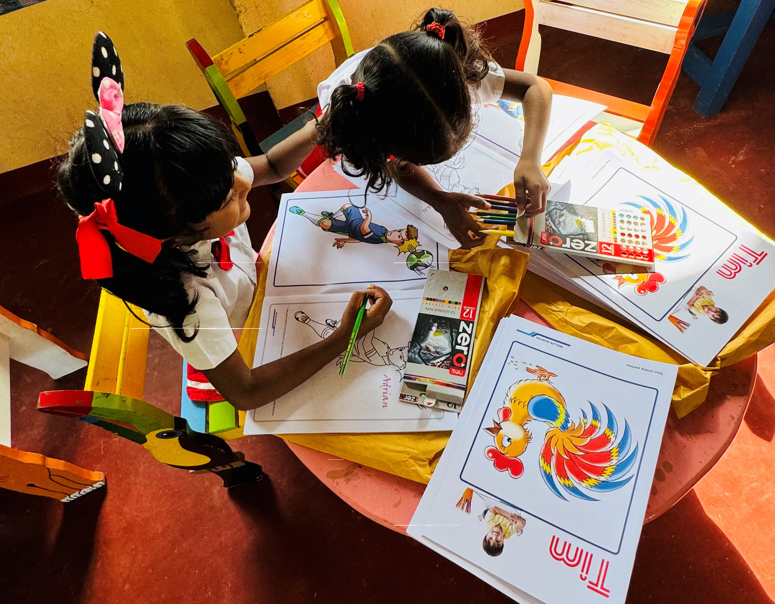

The children in the kindergarten, which the Ayurveda Shunyata Villa in Sri Lanka supports as a social project, are delighted with the coloring books donated by Muller Martini from the production at the Print Finishing Center in Zofingen.

