Media information

Date 07.10.2024
No. PI 2442
Number of signs 1453
Contact Müller Martini AG
Untere Brühlstrasse 17, CH-4800 Zofingen/Switzerland
Telephone +41 62 745 45 45
info@mullermartini.com, www.mullermartini.com

What was previously produced by hand at Pier Luigi will in future be produced on the BF PRO bookline

The Polish print shop Pier Luigi will soon be able to produce high-quality calendars and notebooks, which were previously (partly) produced by hand, automatically on a BF PRO bookline from Muller Martini.

The family business based in southern Poland is taking the plunge into automation and is investing not only in a new, larger building, but also in new, highly automated machines. In its search for a mid-range perfect binder, the company opted for the BF PRO from Muller Martini.

The fact that Pier Luigi's production was previously mainly manual increasingly limited the company's development, which is why the print shop began looking for a solution to automate its finishing process. After experiencing the machine live at a customer in Germany, the management decided for the Muller Martini machine. The contract has been signed at the drupa booth. For Aleksander Skoczen, Vice President at Pier Luigi, the fast make-ready of the BF PRO was an important point. The company was also looking for a reliable and long-term partner, which it found in Muller Martini.

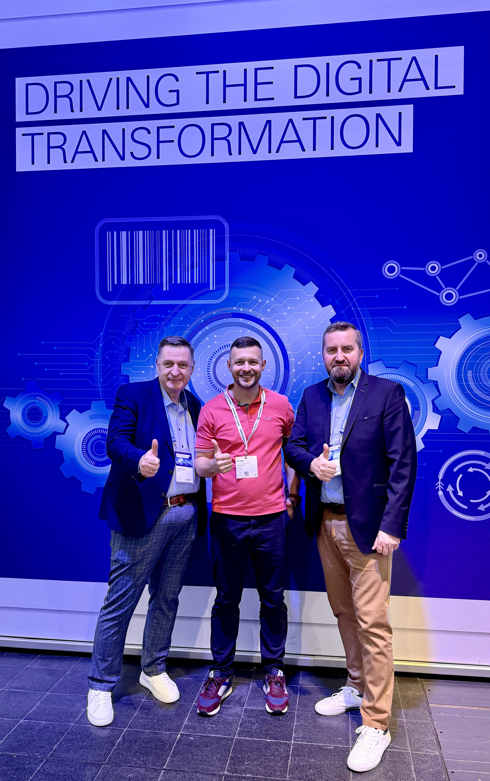
Looking forward to the new BF PRO bookline from Muller Martini: Aleksander Skoczen, Vice President at Pier Luigi (center) together with Jacek Kobylinski, Sales Manager Müller Martini, and Mariusz Mitura Müller Martini, Service Manager, both Region Eastern Europe, at the drupa booth.

