Media Information

Date 5/28/2024
No. PI 2439
Number of characters 2709
Contact Müller Martini AG
Untere Brühlstrasse 17, 4800 Zofingen/Switzerland
Phone +41 62 745 45 45
info@mullermartini.com, www.mullermartini.com

Müller Martini Booth Full on First Day of drupa

With the doors to drupa barely opened, Müller Martini booth 1B50 already started to fill up. The first visitors were impressed by the four connected systems, including the world premiere of the Starbook Sheetfolder from Hunkeler.

Live demonstrations at the booth confirm: Müller Martini actually lives by the drupa motto, “Driving the digital transformation.” Müller Martini is presenting four connected production lines that show live how Müller Martini accompanies its customers on their path to an increasingly digitalized future with state-of-the-art equipment, both in conventional and digital production. The world premiere of a Hunkeler solution in the booth also presents proof that Müller Martini is now an even stronger partner for end-to-end solutions, especially in the growth segment of book production of small print runs.

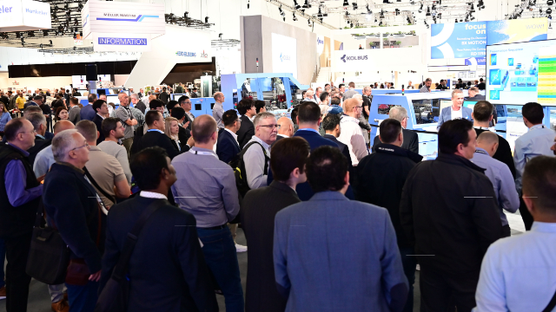

The following solutions clearly show how Müller Martini solutions help harness the full potential of new technologies.
- With the world premiere Starbook Sheetfolder from the Hunkeler range, the audience experiences how digitally produced signature sheets are transformed into glued book blocks, which then move on to inline processing in the Vareo PRO perfect binder.
- An innovative, compact smart factory solution made up of the unbeatable trio of the SigmaLine Compact book block line, the Antaro Digital perfect binder, and the InfiniTrim trimming robot puts out four different digitally produced products – touchless, without any manual intervention.
- The Primera PRO, the popular “workhorse” in saddle stitching, presents new functions and additional optimizations for the continuous production of many small jobs with reduced staff.
- Book blocks are produced both conventionally and in VDP mode on a Ventura MC 200 book sewing machine and a VFN 700 fold hold-down press. This winning combination is followed by a Cobot Omega 693 from Solema.

One crucial factor for digital transformation is the open architecture of the Müller Martini Connex workflow system. All Müller Martini and Hunkeler systems at the booth are integrated in Connex. It is impressive how Connex covers all the functions required for taking all variants and influences in the production process into account dynamically and without manual intervention.

And the service area of the booth was also bustling with activity. The MPOWER ^{MM}Services tools and the benefits of augmented reality as well as artificial intelligence in remote applications were very well received by the audience.

At the end of the first day of the fair, Müller Martini invited guests to the legendary “Blue Hour,” which wrapped up the first exciting day in a pleasant atmosphere.

