Media information

Date 21.09.2023

No. PI 2364

Number of characters 4272

Contact Müller Martini AG

Untere Brühlstrasse 17, 4800 Zofingen/Switzerland

Telephone +41 62 745 45 45

info@mullermartini.com, www.mullermartini.com

New perfect binder family from Müller Martini

**Two new perfect binders: Antaro and Antaro Digital**

**With the new Antaro, which is available in two versions, Müller Martini is launching a compact perfect binder platform that is suitable for highly flexible use. In the OnDemand sector, it can produce digital single books at up to 2000 cycles per hour - an output rate that no other machine on the market today can match, and with the lowest staffing levels. In the conventional version, it delivers up to 4000 cycles per hour.**

The Antaro family enables digital nearline or inline production as well as conventional production, and in doing so caters for a wide range of customer requirements. At the same time, it offers a high level of investment protection, because the system can be expanded and adapted on a modular basis. The following applications are possible:

* **Antaro Digital:** Fully automated single book production with manual feed or inline connection to the SigmaLine Compact digital book production system. With six clamps, up to 2000 individual books can be produced per hour.
* **Antaro:** In combination with a gathering machine, a three-knife trimmer and equipped with 12 clamps, the Antaro is suitable for the production of offset jobs and achieves an output of 4000 cycles/h.

*The new Antaro perfect binder platform achieves unparalleled output for both digital (2000 cycles/h) and offset (4000 cycles/h) printed products.*

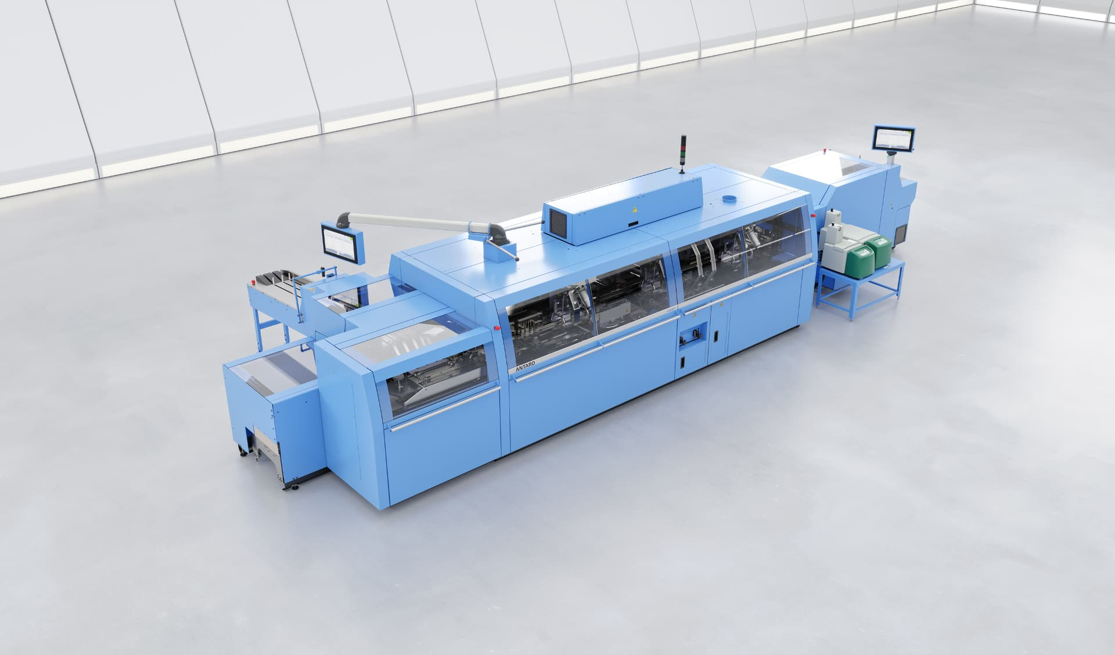

Thanks to its compact design, the Antaro Digital realises a unique output rate over a comparatively small area. In addition, compared to current single-book production solutions, the new digital perfect binder achieves the same output with fewer than half the operators.

**Highly automated single book production**

All Antaro variants have a continuously running swing clamp system. The book blocks are transported in horizontally, standing on their spines and are reliably retained by the clamps, which are always fully open. In addition to the swing clamp principle, the large clamp pitch of 610 mm in the Antaro Digital enables the continuous production of brochures with a block thickness variance from book to book of up to 20 mm at the highest performance level. The thicknesses are changed over fully automatically, ensuring unique productivity of up to 2000 copies per hour for digitally printed individual products.

**Top class end products**

The Antaro produces with two spine milling stations, therefore guaranteeing perfect spine machining. Replacing the gluing units is simple. The system uses EVA and PUR, as well as a glue monitoring system in the PUR nozzle, which controls correct application of the glue.

In the digital version, the newly designed drum cover feeder combined with a cover buffer wheel guarantees reliable separation of the covers. On the other hand, it enables uninterrupted efficient production thanks to continuous feeding. A barcode reader ensures that the book block and cover fit together securely.

The buffer wheel creates a sufficiently long distance between the barcode reading point of the fed book block and the barcode detection of the associated cover. If a mismatch occurs, it is always possible to respond automatically without having to stop the books already in the binding process. In combination with the cover ejection (which is also standard here and is positioned in front of the scoring device), waste is effectively prevented and a whole new level of productivity is achieved.

**Unbeatable variability**

The newly developed Antaro unites the tried, tested and familiar technology from Müller Martini systems and combines it with new features. It processes all conventional types of book blocks such as signature stacks, pre-glued or thread-sewn book blocks or single-sheet stacks, whereby these can be ergonomically and easily fed manually if no inline connection is available.

The new perfect binder platform also brings its full flexibility to bear when it comes to the end products - depending on the equipment level, softcover brochures, hardcover book blocks, flex brochures, glued book blocks and layflat brochures (such as Swiss or Otabind brochures) are all possible. Incidentally, the Antaro Digital has the ideal partner for fully variable Smart Factory production in the InfiniTrim trimming robot.