Media information

Date 17.05.2023
No. PI 2385
Number of characters 2271
Contact Müller Martini AG
Untere Brühlstrasse 17, 4800 Zofingen/Switzerland
Phone +41 62 745 45 45
info@mullermartini.com, www.mullermartini.com

Growth Needs Innovative Technology

The Roser printing company from Salzburg in Austria is repositioning itself in postpress with the Primera PRO saddle stitcher from Muller Martini and is thus ideally equipped for its continuous growth course.

In recent months, the Roser printing company has caused a sensation internationally with its "Energy Community" theme. Even the German edition of "National Geographic" picked up on the topic and wrote an article with the headline "My energy, your energy".

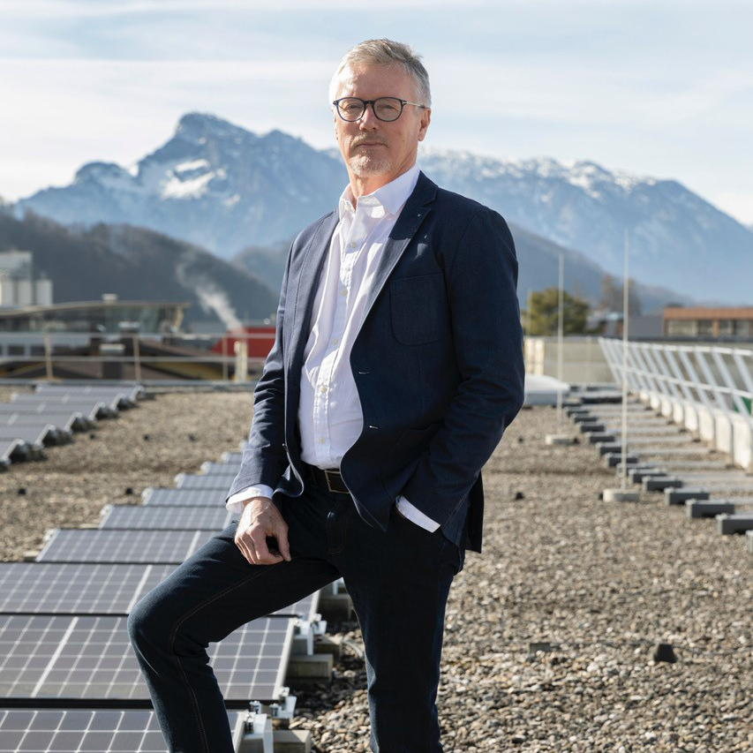
Peter Buchegger (Managing Director Roser): "We are growing against the industry trend."

"The media presence has helped us to position Roser across the border as a sustainable print service provider," says Managing Director Peter Buchegger. This is also reflected in the continuous growth rates of recent years. "We are growing against the industry trend." To be able to handle this growth in the future, the "Roser 2025" sustainability strategy is backed by a comprehensive investment plan.

Capacity expansion in saddle stitching
Recently, the Salzburg-based company decided to commission a Primera PRO from Muller Martini with a cover feeder, four vertical pile feeders, two flat pile feeders and Robusto compensating stacker with center cut and will significantly expand its capacity with the new saddle stitcher. This will happen on two levels – on the one hand through the performance of 14,000 cycles per hour and on the other hand through the reduction of makeready times.

With the Primera PRO, both short runs and long runs can be processed efficiently. "The Primera PRO gives us the flexibility that the market expects from us," emphasizes Peter Buchegger. In addition, the saddle stitcher will be equipped with numerous options for addressing, personalization, for postcard stickers and much more to cover an even wider range of jobs. The company will also offer the increased capacity associated with the installation of the Primera PRO saddle stitcher to other print service providers in the region in order to achieve optimum utilization. Thanks to the use of innovative drive and control technology as well as the MMRemote service module, the investment in the Primera PRO has a positive effect on the carbon footprint of the Roser printing company.

