Media information

Date 6.6.2024

No. PI 2449

Number of characters 2668

ContactMüller Martini AG

Untere Brühlstrasse 17, CH-4800 Zofingen/Switzerland

Phone +41 62 745 45 45

info@mullermartini.com, www.mullermartini.com

**“Customers can make individual choices with MMServices.”**

**The topic of Smart Services from Muller Martini is attracting a great deal of interest at drupa 2024. Live demonstrations at the Muller Martini booth in Hall 1, 1B50, show visitors the added value of the individual components from the** [**MMServices program**](https://www.mullermartini.com/en/services/)**. This has already resulted in numerous sales deals for service products.**

"Our [MMInspect program](https://www.mullermartini.com/en/services/#Inspect) particularly impressed visitors and customers at our booth, and we were able to close a number of deals here," summarized Wolfgang Kurz, Head of the Support Competence Group Rahden, Muller Martini, shortly before the end of the trade fair. Contracts were also signed for MMMaintenance and [MMImprove](https://www.mullermartini.com/en/services/#Improve) (training). Two customers decided to upgrade their [InfiniTrim](https://mullermartini.com/en/products-en/softcover-production/trimming/infinitrim/) trimming robot, and Muller Martini will soon be relocating the [SigmaLine Compact](https://www.mullermartini.com/en/products-en/digital-solutions/digital-bookblock-production/sigmaline-compact/) for another customer. Wolfgang Kurz: "Customers can choose whichever service they need from our comprehensive service portfolio."

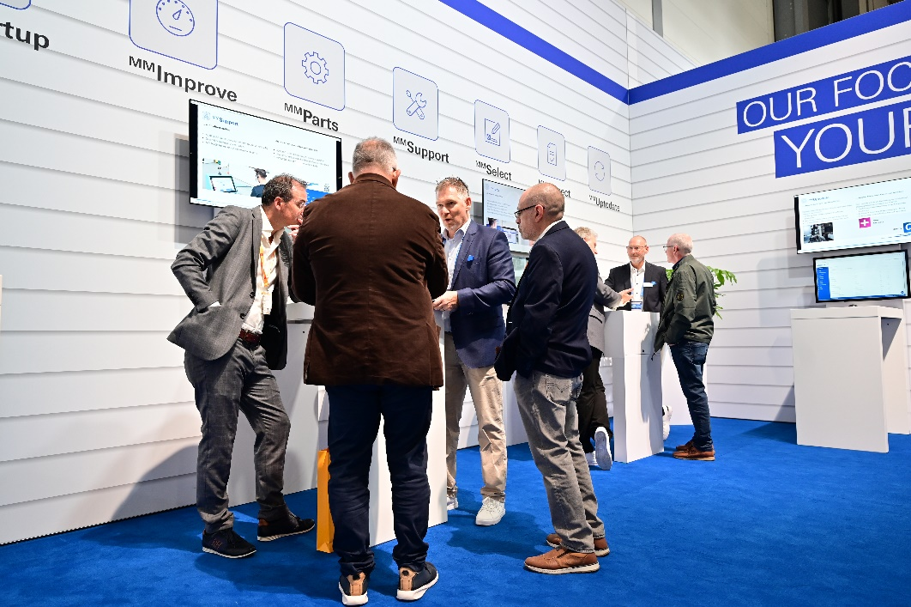

*Interested customers in the service area at the Muller Martini drupa stand.*

The trade fair also shows that the pure "break & fix" approach is becoming less and less important. "Today's customers expect a planned, structured and pre-budgeted service. Our first step is to analyze the customer's business model and we develop an individual service concept," says Wolfgang Kurz, explaining the approach of [MMServices](https://www.mullermartini.com/en/services/). Digital print shops in particular, but also book and brochure manufacturers, are specifically interested in Muller Martini's range of services.

Lifecycle management is a key topic. Here, Muller Martini supports its customers with a proactive service that covers the entire service life of an investment. This ensures a high level of system availability, which directly benefits productivity. The first point of contact in a service case is the Muller Martini Support Center, which is staffed around the clock and provides the customer with a quick solution to the problem. The response times for on-site service are also very flexible and extend to "peak service support" around the clock.

Customers have given extremely positive feedback for the Muller Martini eShop. Thanks to its user-friendliness, a large number of spare parts orders are already being processed via the platform. "With our MMServices program, we have taken on a pioneering role in the finishing sector. We have clearly separated the individual areas and therefore also provide transparent pricing," assures Wolfgang Kurz. In addition, Muller Martini will continue to rapidly expand its MMServices program. The use of artificial intelligence will give a further boost to Muller Martini's service activities.