Media Information

Datum 18.05.2022
Nr. PI 2340
Anzahl Zeichen 3'131
Kontakt Müller Martini AG
Untere Brühlstrasse 17, 4800 Zofingen/Schweiz
Telefon +41 62 745 45 45
info@mullermartini.com, www.mullermartini.com

The Alegro increases competitiveness
The Polish company Books, whose printing division operates under the brand name Konińska Drukarnia Dziełowa (KDD), is implementing an investment package in the softcover sector end of 2022. Muller Martini's Alegro perfect binder will help the company achieve the required productivity even for short runs.
«Currently, our business is characterized by two trends», says board member Mariusz Napierała. «On the one hand, we welcome the return of production from the Far East to Europe, on the other hand, inputs continue to decline. We are reacting to this in all departments, and with the Alegro from Muller Martini we are providing the necessary reinforcement for straight binding.»
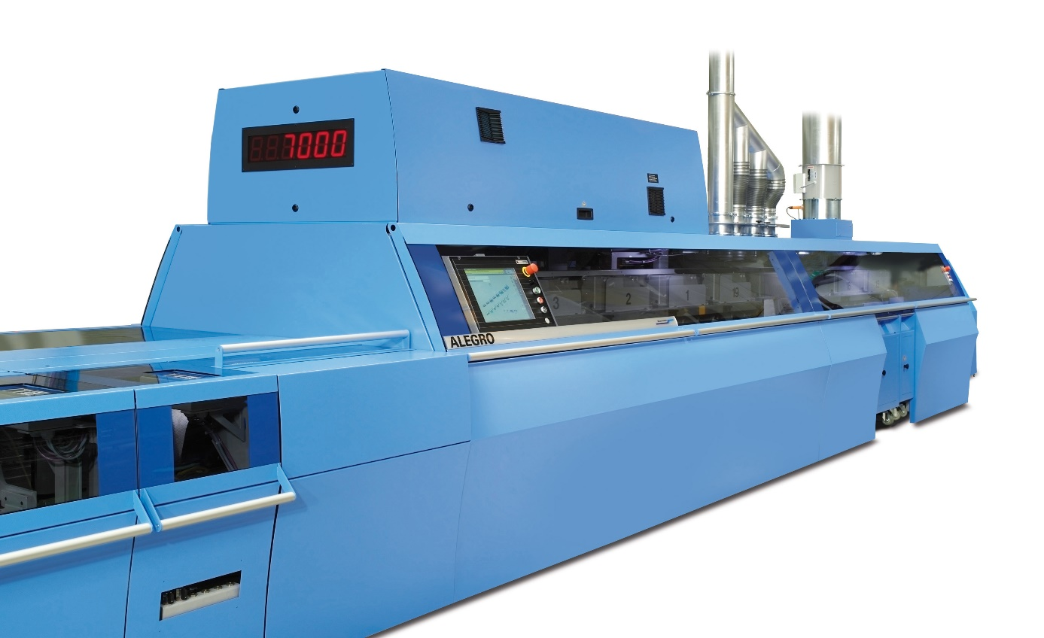
With the Alegro from Muller Martini, KDD introduces the necessary reinforcement for perfect binding in-house.
Books' history dates back to 1998. The company's connection with books was born de facto already in the cradle, as the owners started in the book trade and then also got into the publishing business. At present the printing house employs over 90 people in two production sites in Konin and Nowe Miasto Lubawskie. The bindery is highly advanced in terms of production technology and produces both soft-cover and hardcover books. Saddle stitching and thread sewing round out the offer.
Muller Martini and KDD have enjoyed a trusted partnership for many years – also in the binding sector. Here, the company has been using the Acoro A5 perfect binder from the very beginning with great success, which has contributed significantly to the company's positive economic development. In addition, KDD has a Presto saddle stitcher, a Ventura thread sewing machine and a Diamant bookline – all from Muller Martini.
«Our second location did not have its own binding machine until now. Alegro will fill the gap in the technological chain there and thus significantly speed up production», Mariusz Napierała is pleased to state. The Alegro perfect binder will be used in combination with a gathering machine ZTM and the three-knife trimmer Solit PRO.
Due to the high degree of automation of the Alegro machine, it will also be possible to become more competitive in the production of short runs. In addition to straight binding production, the Alegro machine can also prepare blocks for hard cover casing-inn – thanks to an integrated end sheet tipper and gauze station, which are then hung on the Diamant line.
Despite the increasing level of automation in both printing plants, the key to success is an experienced and committed team of employees, says the board member. In addition, the company, whose investment project is supported by funds from the Operational Program Intelligent Development (OPIR), which is financed by European Funds, has had very good experiences with the previously installed Muller Martini solutions and appreciates the service quality of the Swiss machine manufacturer.

