Press Release

Date 31.10.2018
No. PI 2161
Number of characters 2367
Contact Muller Martini AG
Untere Brühlstrasse 13, CH-4800 Zofingen/Switzerland
Tel. +41 (0)62 745 45 75, Fax +41 (0)62 751 55 50
info@mullermartini.com, www.mullermartini.com

Step by Step Makes It Complete

After putting a Pantera perfect binder into operation, German media company Plump expanded its softcover segment into a complete line and increased both its volume and quality.

The modular design of the Muller Martini equipment was the ideal basis for the company, which is located in Rheinbreitbach, to take advantage of the “step-by-step” purchase option. After seeing an increase in the number of orders produced on the Pantera, which the company purchased in 2015, Managing Director Bernd Plump invested in a 3692 gathering machine with an Asir 3 in 2017, and this year he completed the softcover line with a Granit three-knife trimmer and an Uno compensating stacker. The increase in production quality helped the media company to strengthen its good reputation. In addition, productivity rose by at least 20 percent.
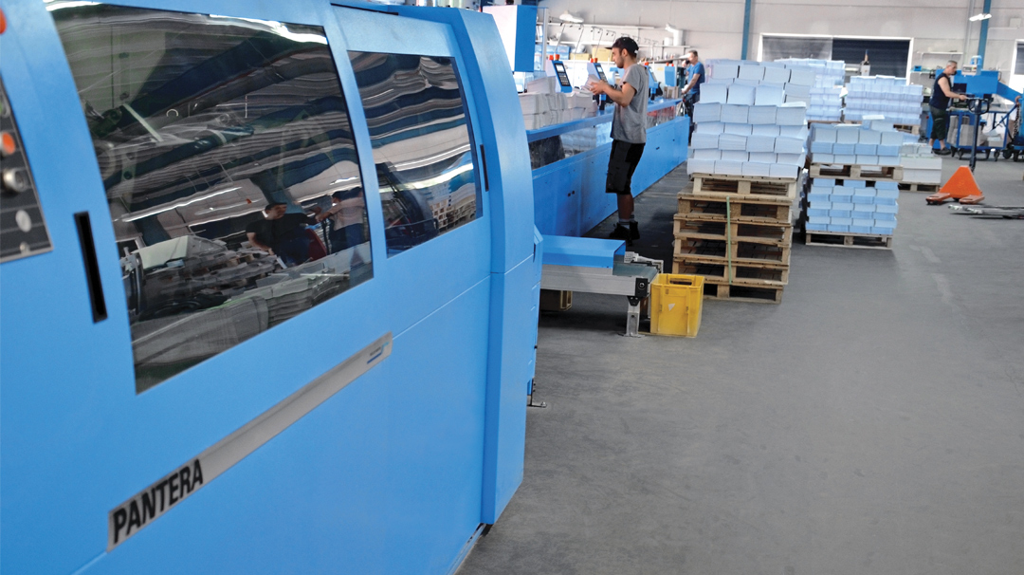
Thanks to the investment in a complete softcover line, Medienhaus Plump has increased its productivity by at least 20 percent.

“With the extended configuration we can now effortlessly handle longer runs in-house too,” says technical manager Serdal Ördek. This is because the new, complete line also comes into its own for runs as long as 30,000 copies per title thanks to process automation. This allows the Pantera to exploit its full performance potential. The average print runs in the softcover segment at the family business, which specializes in reference books in the areas of education, IT, jurisprudence and music, range from 2,000 to 3,000 copies.

The successful upgrades to its perfect binding have led Medienhaus Plump, which employs 65 people, to invest in saddle stitching as well. To this end, the Muller Martini Presto E90, which the company has operated since 2008, is set to be replaced by a Presto II shortly. As this machine also has the Asir 3 signature scanning system and an interface for the JDF/JMF connection, the company expects to see a positive impact on setup times and product quality in saddle stitching as well.

More information will be available on our website below in German and English (switch languages) after the publication date given above.

