Media information

Date 16.11.2022
No. PI 2366
Number of characters 2571
Contact Müller Martini AG
Untere Brühlstrasse 17, 4800 Zofingen/Switzerland
Phone +41 62 745 45 45
info@mullermartini.com, www.mullermartini.com

Learn more about the RF 700 backgluing and backlining machine from Muller Martini in a video

Bookbinders have two options for producing book blocks for thread sewing (gluing and backlining). Either they use a perfect binder, which as an "all-rounder" can also make hardcover book blocks in addition to perfect binding. Or you can use a gluing machine that has been specially developed for thread-sewn book blocks – such as the RF 700 backgluing and backlining machine from Muller Martini. It produces book blocks for thread sewing at up to 70 cycles per minute in perfect quality. Thanks to its high level of automation, book producers save time and personnel.

This is confirmed by Jiří Resl, Managing Director of Tiskárna Resl in Náchod in the Czech Republic: "Until recently, we used the Alegro perfect binder to glue down book blocks for hardcover books. However, this was then often blocked for a long time for the production of softcover books. We therefore installed an RF 700 backgluing and backlining machine, which solved all our production problems in one fell swoop."

In the RF 700, Muller Martini has continuously implemented feedback and suggestions from the market as part of innovations to ensure that it meets the changing requirements of bookbinders. It convinces with several highlights:
Pressing possibilities before and after the line.
Modular configuration options.
Gluing on endpapers, backgluing and back lining – all in one machine.
Processing of a wide variety of glues (cold glue, hotmelt, PUR) for side or one/two-shot spine gluing.
High production speed of up to 70 cycles per minute.
The CoPilot system enables efficient operation and fastest makeready times.
Compact design.

"The investment in the RF 700 has brought us a reduction in delivery times, a reduction in manufacturing costs and an expansion of our production capacity. We can now manufacture many new orders that we couldn't manage in the past," says Jiří Resl. "Because all Muller Martini machines have a similar operating philosophy, we can use our current personnel on the RF 700, which additionally helps to reduce production costs."

Read about the experiences of Muller Martini's Czech customer Tiskárna Resl with its new RF 700 backgluing and backlining machine in this article on the Muller Martini website.

In this blog on the Muller Martini website you can find out more about the RF 700.

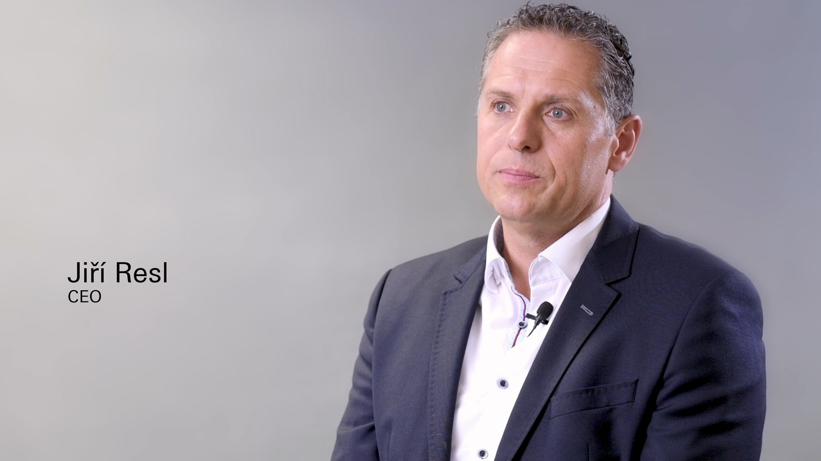
Watch in this video, why Jiří Resl, Managing Director of Tiskárna Resl in Náchod in the Czech Republic, invested in an RF 700 spine gluing and folding machine from Muller Martini.

