Media Information

Datum 03.11.2022
Nr. PI 2362
Anzahl Zeichen 1942
Kontakt Müller Martini AG
Untere Brühlstrasse 17, 4800 Zofingen/Schweiz
Telefon +41 62 745 45 45
info@mullermartini.com, www.mullermartini.com

Zhongke Printing: Two Different Perfect Binders for Different Requirements

Two decades after Zhongke Printing first put a Muller Martini system into operation, the graphic arts company in the Chinese capital Beijing invested in the latest perfect binder technology with an Alegro A7 and a Publica PRO12.

Founded in 1957 by the Chinese Academy of Sciences and employing over 1200 people in two shifts, the full-service print shop is one of the largest producers of textbooks and scientific works for the Chinese domestic market. The total daily production is between 300,000 to 400,000 copies with an increasing number of jobs below 5,000 copies. In addition, magazines are printed for mainly domestic publishers.

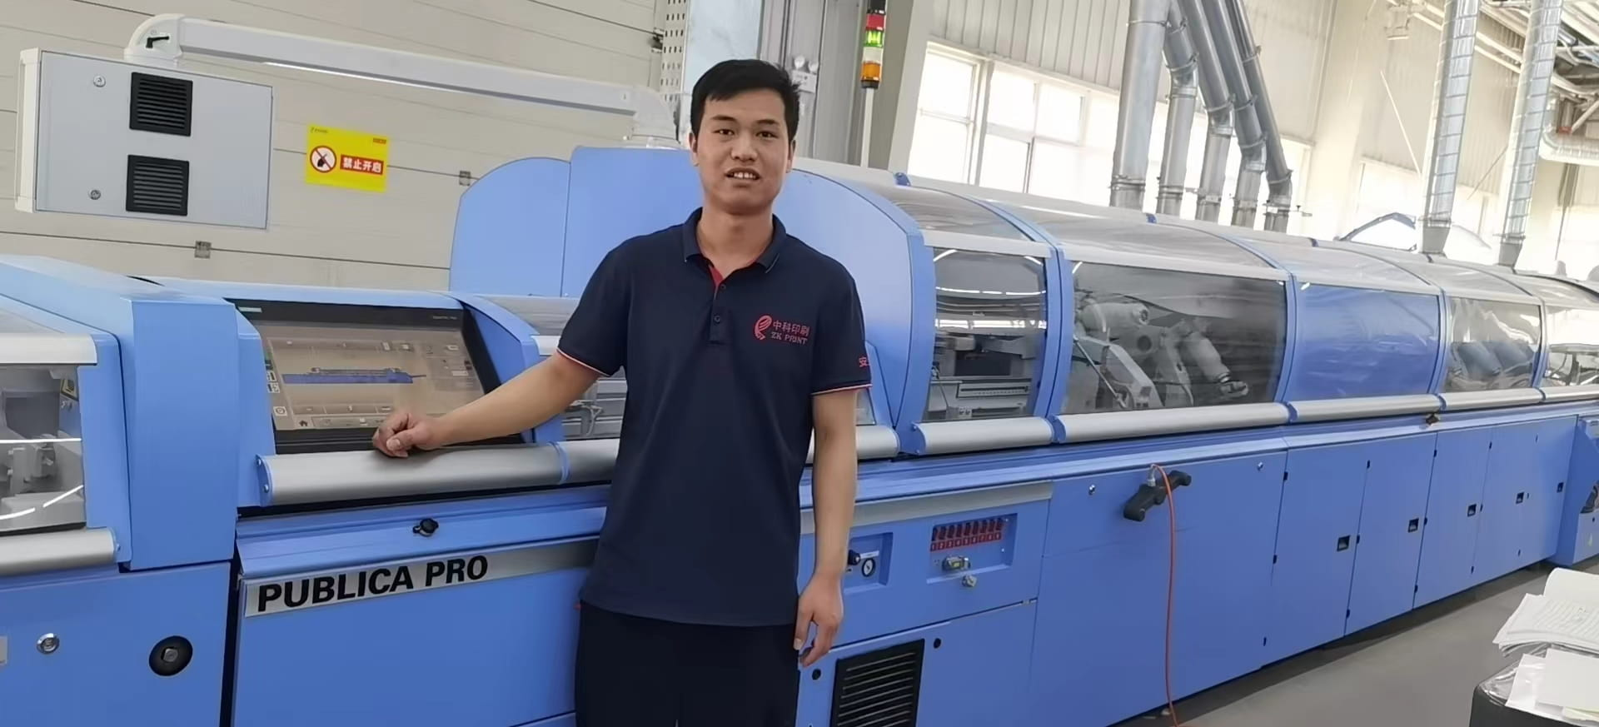Machine operator Yidong Xin in front of the new Publica PRO12 perfect binder at Zhongke Printing.

As a result of the expansion of printing capacity, new market challenges, higher quality demands from customers and the desire to reduce waste, Zhongke Printing modernized its softcover equipment. After the good experience of the past 20 years, the choice again fell on two perfect binding lines from Muller Martini – a Publica PRO12 with a ZU 832 gathering machine, streamfeeder, Orbit three-knife trimmer and CB 18 book stacker, and an Alegro A7 with a ZTM 3694 gathering machine, streamfeeder, Easy Fly PRO front trimmer, double splitting saw, Orbit three-knife trimmer and CB 18 book stacker.

The fact that Zhongke Printing, which is 8 percent digital, opted for two different Muller Martini models is due to its diverse job structure. It uses the Publica PRO12 primarily for teaching materials that have to be bound in a short time. The Alegro A7, on the other hand – keyword front trimmer – primarily produces more complex books. With the commissioning of the two perfect binders, which the machine operators were able to get to grips with in a short time, Zhongke Printing significantly increased its productivity.

