Media-Information

Datum 24.02.2022
Nr. PI 2320
Anzahl Zeichen 1'913
Kontakt Müller Martini AG
Untere Brühlstrasse 17, 4800 Zofingen/Schweiz
Telefon +41 62 745 45 45
info@mullermartini.com, www.mullermartini.com

A Vareo PRO and an EMP 513 for Iraq

Barzayar in the Iraqi capital Baghdad is modernizing its machine park with a Vareo PRO perfect binder and an EMP 513 casing-in machine from Muller Martini.

Founded in 2004 and employing 140 people, the print shop and bookbindery specializes in books and commercial printing. Previously involved exclusively in softcover production – with the Iraqi Ministry of Education and Health as its main customers – it is now expanding its range to include hardcover books. The book blocks are produced on the Vareo PRO and inserted into the EMP 513.

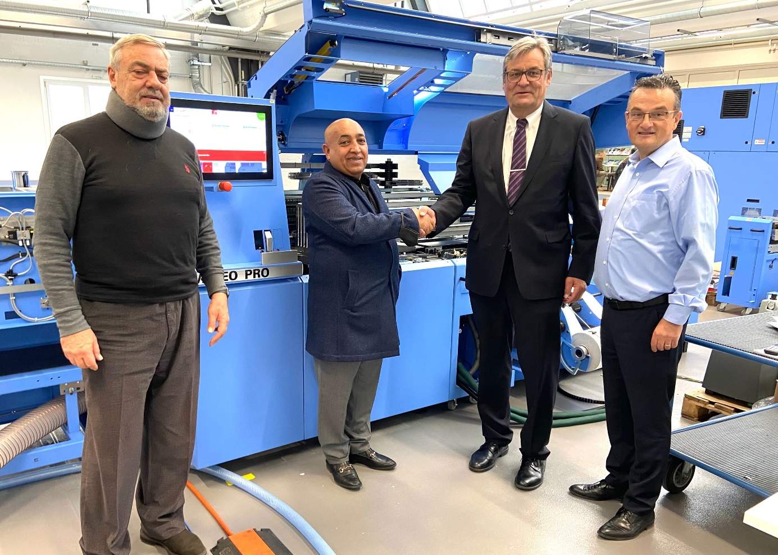

From left: Elie Hamaty (Sales Manager Middle East Graphics, Lebanon), Shakir Alrubaiawi (Managing Director Barzayar), Hans Leuenberger (Managing Director Germany and Direct Markets Muller Martini) and Enrico Farinacci (Regional Sales Director Muller Martini) seal the sale of the Vareo PRO to Barzayar.

"We do not currently have any Muller Martini equipment," says Managing Director Shakir Alrubaiawi. "But I know that Muller Martini stands for high quality, excellent service and technologically leading systems. I was able to see this for myself during my visit to the factory in Zofingen. The Vareo PRO and the EMP 513 are exactly the right machines for us – not only for today, but also for the future."

According to Shakir Alrubaiawi, another argument in favor of the Vareo PRO was "that it is very flexible with regard to a wide variety of book forms and can be easily expanded to meet future market requirements. In addition, the books are produced in the highest quality – just as with the highly automated EMP 513."

Despite current global supply chain and transportation issues, Barzayar will start up the two new lines shortly.

