Press Release

Date 4/21/2020
No. PI 2247
Number of characters 2547
Contact Muller Martini AG
Untere Brühlstrasse 17, 4800 Zofingen, Switzerland
Phone +41(0)62 745 45 45
info@mullermartini.com, www.mullermartini.com

Creative Solution during the Coronavirus Pandemic: Live Demonstration for Customers from the Blue Salon in Rahden

Using Skype for Business, Muller Martini presented the benefits of its KM 610.A perfect binding line via live video to one of its customers who was unable to travel to Rahden for a machine demonstration due to the current travel restrictions.

'Drastic times call for drastic measures', goes the saying, sometimes attributed to British statesman Winston Churchill. This is now also true for Muller Martini during the coronavirus pandemic. As international travel is practically impossible at the moment, creative solutions are needed to maintain contact with customers. This includes, for example, live video demonstrations via Skype for Business from the company’s training center.

And this is precisely what Muller Martini did recently for a Taiwanese customer, presenting the benefits of a complete softcover line with a KM 610.A 8,000-cycle perfect binder, a ZU 805 gathering machine, a VA 424.A endsheet feeder, an FA 650 face trim machine, an HD-HD 143 three-knife trimmer, and a CB 18 compensating stacker. During the live demonstration shown in the customer’s offices more than 9,000 kilometers away, four different products were produced and – using title memory storage and a measuring table – a total of three changeover processes were presented. Products 1 and 2 were perfect-bound brochures in A4 and A5 format, product 3 a perfect-bound brochure with a cover flap (front trimmed using an FA 650), product 4 a milled hardcover book block with endsheets and liner stripes.

Lukas Budde served as the cameraman during the nearly three-hour demonstration. “It was important,” says Budde, the Product Manager Hardcover/Softcover at Muller Martini Bookbinding Systems GmbH in Rahden, “that there was no interruption in the live demonstration to avoid giving the customer the impression that we were hiding something from them.”

Inga Wiens, the responsible Regional Sales Manager, says that the online presentation had a very positive impact. “Everything went smoothly.” The customer’s initial response was enthusiastic as well. “Now,” says Inga Wiens, “we hope they choose our solution.”

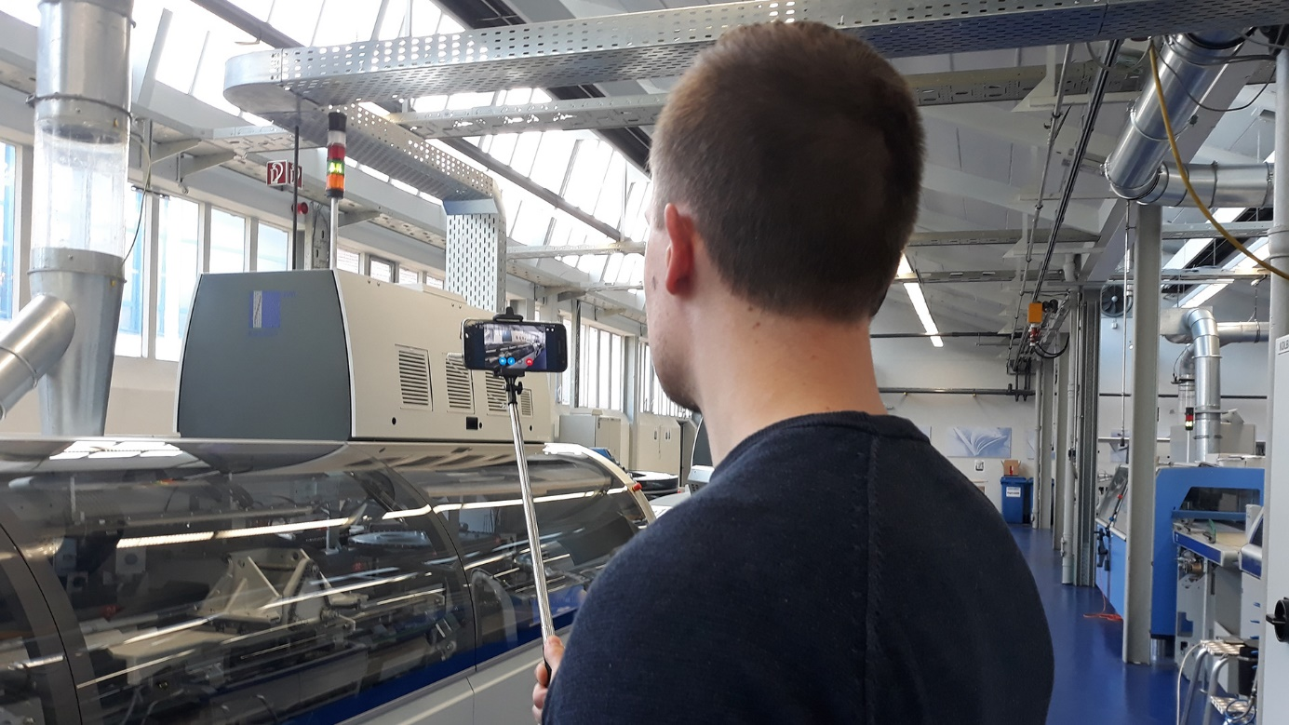
Lukas Budde, Product Manager Hardcover/Softcover at Muller Martini Bookbinding Systems GmbH, served as the cameraman during the live demonstration.

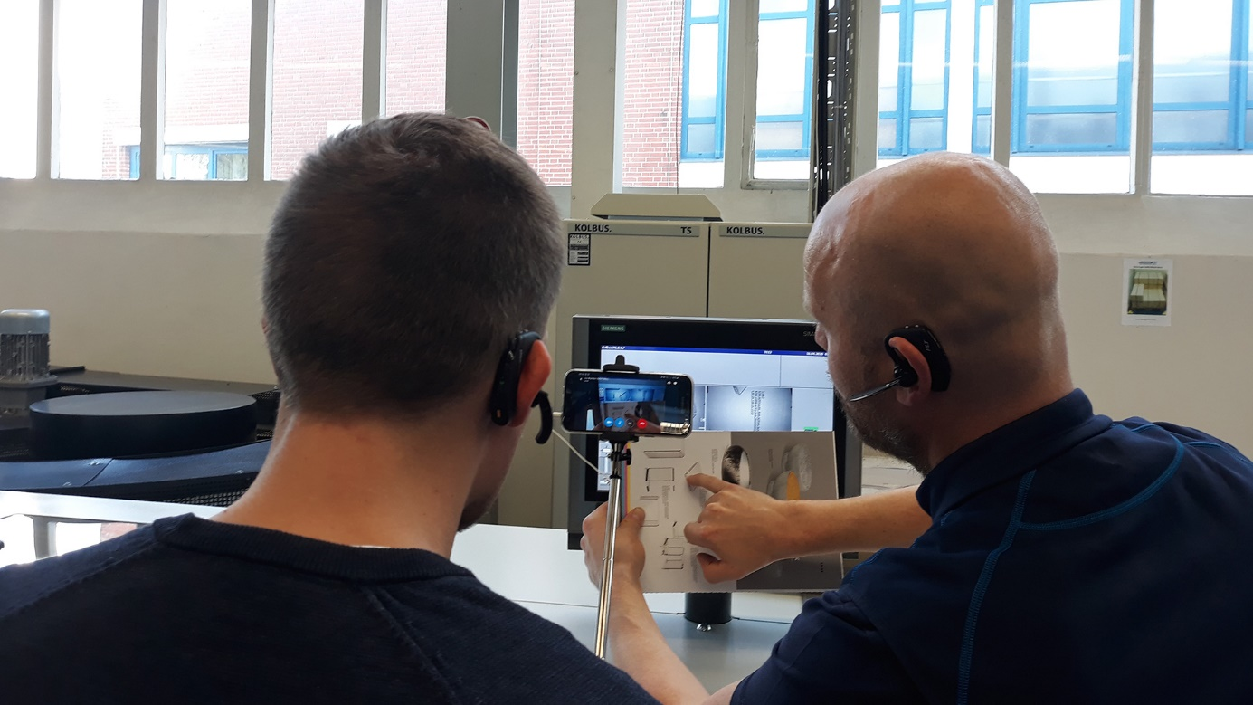
Lukas Budde and Tobias Lintelmann, instructor at the Blue Salon in Rahden and Kolbus brand ambassador, present the benefits of the KM 610.A perfect binding line copilot to the customer

