Media information

Date 01.03.2023
No. PI 2281
Number of characters 2100
Contact Müller Martini AG
Untere Brühlstrasse 17, 4800 Zofingen/Switzerland
Phone +41 62 745 45 45
info@mullermartini.com, www.mullermartini.com

Edubook expands its product range with the Vareo PRO

Edubook in Merenschwand in the Swiss canton of Aargau is expanding its range and strengthening its market position by investing in a Vareo PRO perfect binder from Muller Martini that is predestined for print run 1 products.

Since 2016, the on-demand specialist has relied on a Eurobind EB 1300 perfect binder purchased from Muller Martini. There are several reasons why Edubook is replacing it with a Vareo PRO next May, according to Sergio Nobile, Managing Director and Delegate of the Board of Directors.

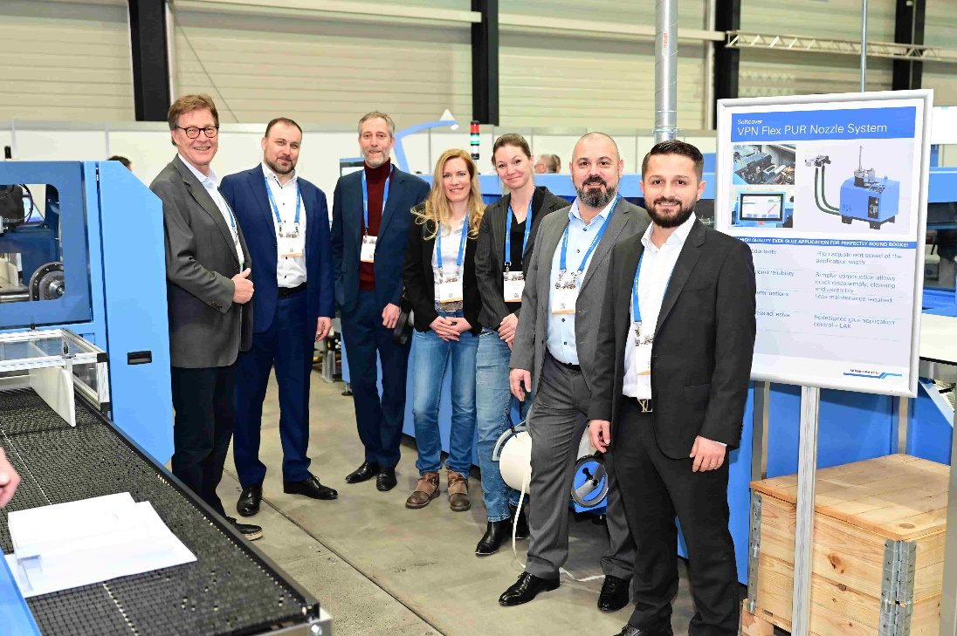
The extended management of Edubook with Managing Director Sergio Nobile (second from right) in front of the Vareo PRO perfect binder at the Hunkeler Innovationdays in Lucerne. On the left, Jules Dietz, Sales Manager Muller Martini Switzerland.

"First, the Eurobind is getting on in years. Second, as a Swiss company, it was our declared intention to rely on a Swiss machine manufacturer. And thirdly, the Vareo PRO – and this is the important USP from a technological point of view – enables us to produce three different products at the same time thanks to its special drive technology: softcover books, free spine brochures and swiss brochures."

With the expansion of its business field and the higher level of automation, "which is in line with our company philosophy" (Sergio Nobile), Edubook, which was founded in 2004 and employs 23 people and produces climate-neutrally and exclusively in Switzerland, underlines its position in the Swiss on-demand market. This is because its customers from the submarkets of industry, publishing houses, associations and educational institutions all come from Switzerland. The print run segment of the exclusively digitally printed products ranges from book-of-one to several thousand copies.

Edubook's Vareo PRO, on which book blocks for hardcover production are also produced, has a PUR nozzle. "PUR binding is standard for us and meets the wishes of many customers. This is because many products have to withstand greater stresses over a longer period of time," emphasizes Sergio Nobile.

