Press Release

Date 06.07.2018
No. PI 2148
Number of characters 2105
Contact Muller Martini AG
Untere Brühlstrasse 13, CH-4800 Zofingen/Switzerland
Tel. +41 (0)62 745 45 75, Fax +41 (0)62 751 55 50
info@mullermartini.com, www.mullermartini.com

Fully Focused on Digital

Southern Germany’s Walter Digital GmbH has given digitalization the green light. The Vareo perfect binder is supporting the company on its growth course.

Growth in the digital business gave the long-established company located in Korntal-Münchingen near Stuttgart, the security it needed to give up the offset printing business in 2016 and focus instead on new technology. The strong positioning in digital printing also called for expansion measures in print finishing. The Vareo from Muller Martini, which the company acquired in July 2017, has the potential to substantially increase perfect bound products. The machine has boosted the company’s flexibility and ability to customize, which is extremely important given the broad range of print runs that can be anywhere from a few copies to several thousand.

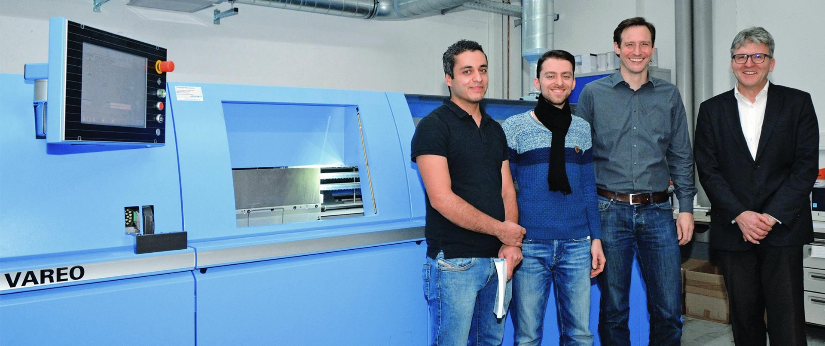
From left to right: Abdallah Al-Chaarawi (Print Finishing Department Head), Mazlum Dülger (Post-Press Technical Manager), Daniel Barth (Production Manager) and Peter Stein (Area Sales Manager at Muller Martini Germany) in front of the new Vareo at Walter Digital.

“Our experience has been incredibly good,” says Mazlum Dülger, the Post-Press Technical Manager at Walter Digital. As the machine’s key advantages, Dülger cites its quick size and job changeovers, low cleaning requirements, sophisticated technical features such as the book vibration device and the nozzle glue application system, and the process-integrated three-knife trimmer.

A digital sheet-fed printer and a roll-fed system form the heart of the modern machine range, which serves some 40 customers daily. As a traditional partner to a variety of companies, including automakers, mail order companies and retailers, Walter Digital aims to create an increasingly direct link with end customers by offering logistic services. For example, the company works with a greeting card company. In the spirit of innovation, it is also testing personalization options by adding a customized cover to the brochure of a mail order company with products tailored to the recipient.

