Press Release

Date 6/23/2017
No. PI 2099
Number of characters 2412
Contact Muller Martini AG
Untere Brühlstrasse 13, CH-4800 Zofingen, Switzerland
Tel. +41 (0)62 745 45 75, Fax +41 (0)62 751 55 50
info@mullermartini.com, www.mullermartini.com

The InfiniTrim Wins an Innovation Award

Muller Martini’s InfiniTrim three-knife trimmer won the award for best “Novel Manufacturing Technology” at the Innovation Excellence Awards of the Stationers’ Company, a British trade association.

“The InfiniTrim three-knife trimmer is not just an improvement on existing book binding systems but a ground-up development with impressive results,” said Tony Mash, Stationers’ Company Industry Committee Chairman, explaining the jury’s decision during the award presentation at Stationers’ Hall in London. In his laudatory speech, he praised the creative technical development process capable of building such a fast book production process.
“The InfiniTrim is a prime example of Muller Martini’s Finishing 4.0 strategy, which revolves around a high degree of automation, connected processes and a digital workflow,” explains David McGinlay, Sales Manager at Muller Martini Great Britain, who accepted the award on behalf of Muller Martini. “We are delighted to receive the Innovation Excellence Award for our ‘best in class’ innovations.”

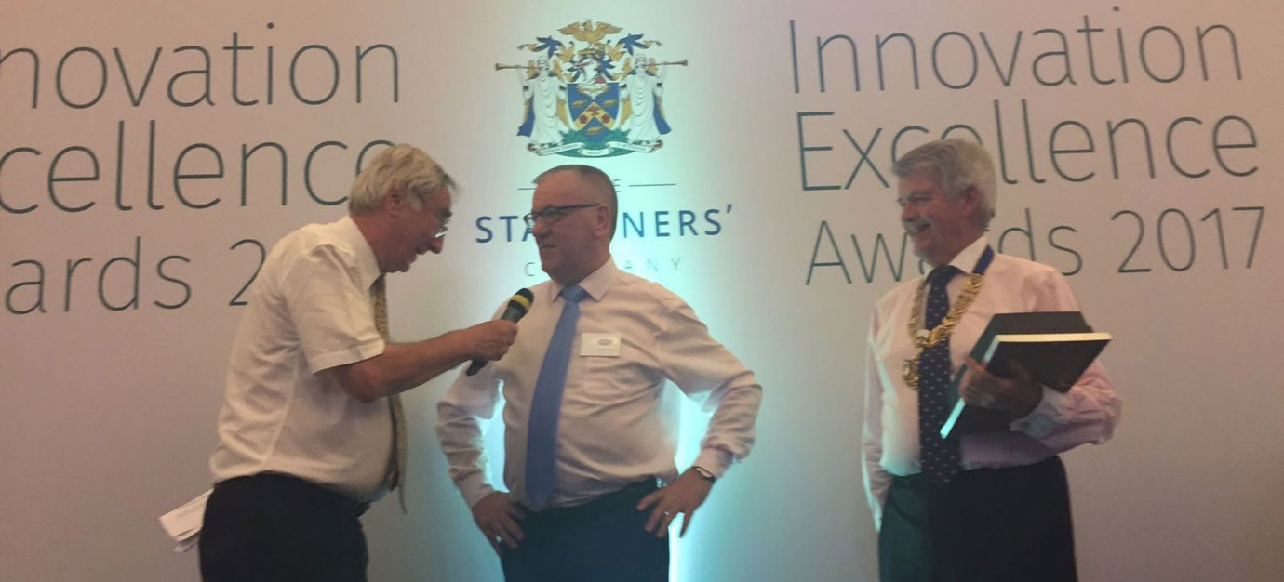

David McGinlay, Sales Manager at Muller Martini Great Britain (middle), upon presentation of the award by Ian Bennett, Master of the Stationers' Company (right), and Peter Day, BBC Journalist and presenter of the event: “We are delighted to receive the Innovation Excellence Award for our ‘best in class’ innovation”

The InfiniTrim three-knife trimmer, which has a revolutionary drive, transport and trimming concept, is clearly superior to comparable machines in terms of net output and flexibility. “Thanks to the separate drives of all knives and grippers, no set-up process is required, which enables production with a touchless workflow,” explains David McGinlay. “That makes it ideally suited to short and ultra-short runs right down to runs of one copy.”

The Innovation Excellence Awards of the Stationers’ Company, the City of London Livery Company for the Communication and Content Industries, promote new developments in the communications industry. The new “Novel Manufacturing Technology” category rewards the best innovations in the fields of printing, publishing and the packaging industry. Muller Martini beat off competition from IST Technologies, Baldwin Technology Company and Heidelberger Druckmaschinen AG to win the award.
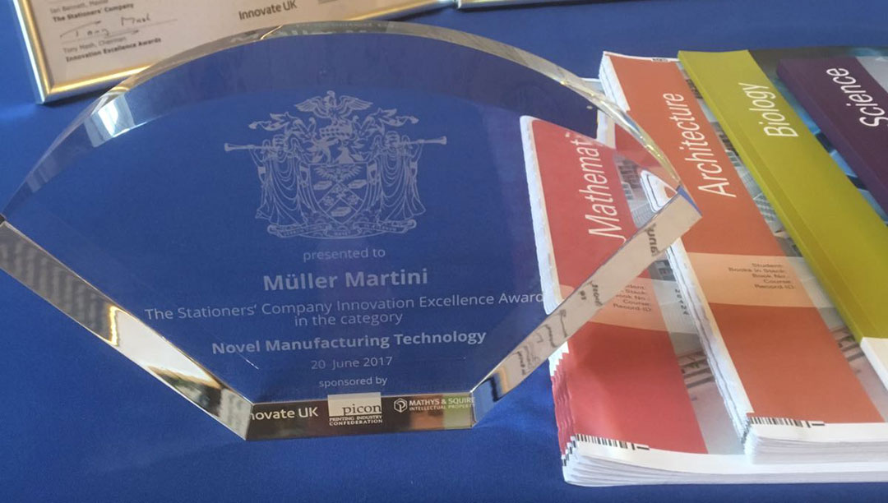

The Innovation Excellence Awards of the Stationers’ Company, a British trade association, promote new developments in the communications industry.

