Press Release

Date 26.09.2019
No. PI 2225
Number of characters 3966
Contact Muller Martini AG
Untere Brühlstrasse 17, 4800 Zofingen, Switzerland
Tel. +41 (0)62 745 45 75, Fax +41 (0)62 751 55 50
info@mullermartini.com, www.mullermartini.com

Mailroom Days at Oppermann –
Deep Insight Into Technology

Muller Martini and Oppermann Druck und Verlag GmbH & Co. KG invited mailroom specialists to the north German town of Rodenberg for two days. The visitors had the chance to take a look behind the scenes of Europe’s most state-of-the-art mailroom and see for themselves how five daily newspapers and 50 weekly newspapers are produced using a total of three ProLiner newspaper inserting systems.

The Mailroom Days met with particular interest this year because Muller Martini is not participating in the IFRA World Publishing Expo newspaper industry trade fair. “Instead we wanted to give traditional newspaper producers and customers in the inserts segment an ideal platform for exchanging views and networking with professional colleagues,” explains Hans Leuenberger, Regional Director at Muller Martini for Germany/Switzerland/Direct Markets.

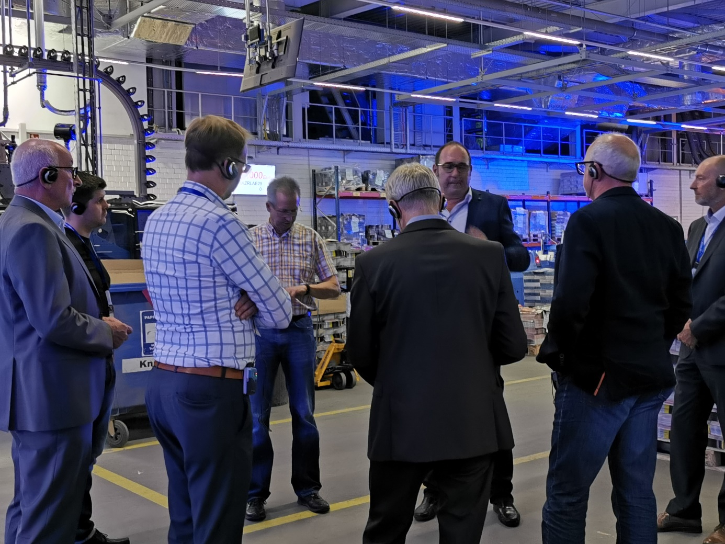
By putting on the Mailroom Days in Rodenberg, Muller Martini provided traditional newspaper producers and customers in the inserts segment with an ideal platform for exchanging views and networking with professional colleagues.

Muller Martini’s idea of presenting leading topics in the newspaper industry – such as efficiency enhancements, cost optimization, and workflow solutions for insert handling – live and with a view to sustainable success, went down well with the numerous Mailroom Days visitors in Rodenberg. “Such an event provides deeper insight into the technology,” commented Dr. Bertram Stausberg, Managing Director of Axel Springer Print Management GmbH in Ahrensburg (Germany). “More time was available, any questions that arose during live production were answered there and then, and there was a useful exchange of views and ideas. Getting a range of newspaper industry professionals together gave me new perspectives.”

Alexander Ströhle, Managing Director of Intergraphik GmbH in Innsbruck (Austria), which belongs to Moser Holding AG, also highlighted that aspect: “At IFRA, you speak to people but don’t see the technology.” Steffen Rothe, Print Finishing Production Manager at Pressedruck Potsdam GmbH in Potsdam (Germany), found such an event to be “more genuine than a meeting at the trade fair”. “For me, the event had great practical relevance and gave me a look behind the scenes. I found talking to the machine operators particularly beneficial.”

The Mailroom Days at Oppermann Druck und Verlag GmbH & Co. KG were of particular interest because the renowned newspaper producer has significantly increased the efficiency of its newspaper inserting process by using one instead of two inserting machines. “With one Muller Martini ProLiner, we can handle the same insert volume as before with two SLS3000 lines,” notes Niels Rohrsen from Oppermann.

The visitors could see the truth of that statement for themselves. They saw first-hand how Oppermann now uses three ProLiners – two of which were commissioned a while ago – to produce five daily newspapers with a total run size of 250,000 copies, and 50 weekly newspapers with a total of 2.63 million copies for its own publishing company and for external customers, and inserts over 1.25 billion inserts yearly.

The three Muller Martini inserting lines, which are fed from FlexiRoll buffers, run at up to 45,000 cycles per hour, have fully automatic changeovers, are equipped with 20 insert feeders each, automatic main section and preprinted section feeding and three FlexPack bundle builders each, and can process both the Rhenish and Berliner formats. They are managed by the Connex.Mailroom control system for an optimal production overview and seamlessly connected production processes.

Alexander Ströhle was “impressed by the calm organization and production”, especially given the massive volumes involved. Dr. Bertram Stausberg was “impressed that the production runs without machine stops”. And Steffen Rothe was fascinated by the “high production stability and production reliability”.

