Press Release

Date 10.09.2019
No. PI 2214
Number of characters 2399
Contact Muller Martini AG
Untere Brühlstrasse 13, CH-4800 Zofingen/Switzerland
Tel. +41 (0)62 745 45 75, Fax +41 (0)62 751 55 50
info@mullermartini.com, www.mullermartini.com

A Duo Causes an Uproar at Bonacia

Bonacia, located in the English city of Peterborough, wondered about the future of bookbinding and found the ideal answer in the Vareo/InfiniTrim inline duo.

The family company did not want to hold on to the old system. Its previous perfect binder and three-knife trimmer were in operation around the clock in 2019 – with a corresponding risk of failure and high wage costs. With its investment in the Vareo perfect binder and InfiniTrim three-knife trimmer from Muller Martini, the company’s management team gave preference to an inline solution, despite the higher purchase costs. The lower estimated annual operating costs were the main reason for choosing it over a competing machine with an offline three-knife trimmer. Not only that, there are also tax deductions and no more shifts or overtime.

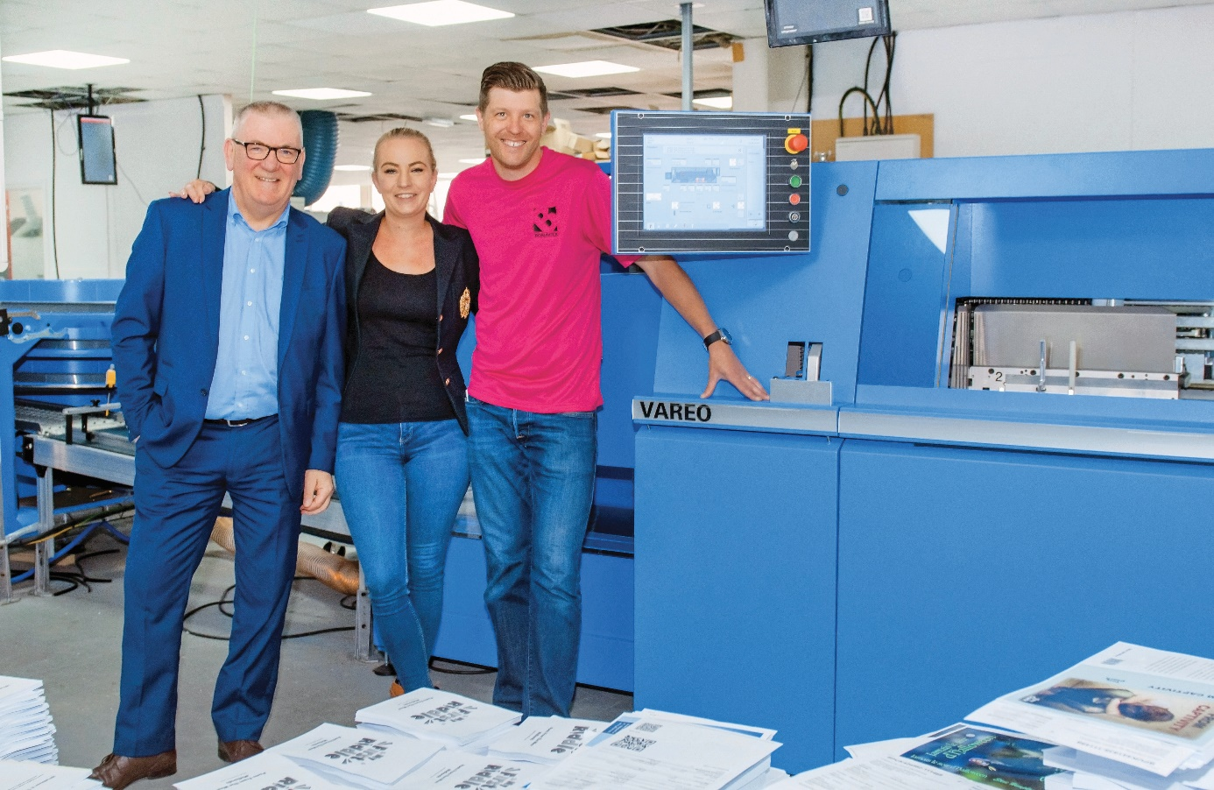
Bonacia managers Carl Whitelock (right) and Rosie Whitelock together with David McGinlay (Sales Manager at Muller Martini UK) standing in front of the Vareo perfect binder.

The company, which has been producing all of its products digitally since the Vareo and InfiniTrim were commissioned, prints 30,000 books a week – 13,000 more than before. Instead of the four hours it took with its old offline solution to bind 500 copies, it now takes just 30 minutes. However, for Director Carl Whitelock other advantages that cannot be quantified in figures are also important: “The Vareo and InfiniTrim provide us with greater size variability, accelerate book-of-one production, prevent mismatching of content and covers thanks to barcodes and result in considerably less production waste.”

The company, which was founded ten years ago and now has 92 employees, has increased its order volume further with the help of the inline duo from Muller Martini. The leaner workflow is especially important for Bonacia because the plant in Peterborough produces 60 run-of-one products every day. The company, which has won numerous awards, also has the option of producing hardcover book blocks industrially in runs of one in the future by adding an endsheet feeder. Hardcover books currently make up 16 percent of the sales volume at Bonacia.

