Press Release

Date 22.03.2018
No. PI 2128
Number of characters 1735
Contact Muller Martini AG
Untere Brühlstrasse 13, 4800 Zofingen, Switzerland
Tel. +41 (0)62 745 45 75, Fax +41 (0)62 751 55 50
info@mullermartini.com, www.mullermartini.com

Improved Production Flow

Assisted by the expertise of ^{MM}Services, Schär Druckverarbeitung AG has improved its workflow production and ensured the family business has a promising future by relocating to a new site.

Sometimes ten kilometers can make all the difference. That is the distance between the company’s old, labyrinthine, three-story production site in the municipality of Rothrist on the Swiss Plateau to its newly built, two-story building – which is a third larger than the previous site – in Wikon. The relocation puts an end to a laborious way of working that required numerous adjustments. The new site provides space for almost the entire machine line-up that was previously in use, including three Muller Martini saddle stitchers, namely a Prima S Amrys, a 235, and a 221, and their peripheral devices. Moreover, the site is readily accessible for trucks.

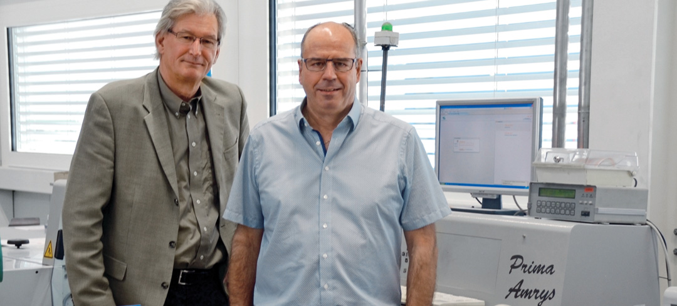The three Muller Martini saddle stitchers were deinstalled and reinstalled within four weeks.

“Our machines are now logically positioned and the production sequence is better organized. We can produce far more cost-effectively than before and respond even more flexibly to customer requirements,” says Managing Director and owner Paul Bucher. The successful relocation of the company site was enhanced by the fact that the machine line-up was relocated quicker than scheduled, within just four weeks. Not only were the three saddle stitchers thoroughly cleaned before the reinstallation, the Muller Martini experts reconditioned all the feeders and three-knife trimmers following an extensive inspection. The replacement of belts and other wear parts has made the setup process quicker.

Schär Druckverarbeitung AG, which provides 35 full-time jobs and has a promising outlook as a family business thanks to the next generation, produces 95 percent of its volume for printing plants. The company specializes in ultra-small and ultra-large products with contour die cutting, folds of all kinds, inline rotary die cutting, pocket folders, diaries and self-mailers.

