Wikon, Switzerland, April 23, 2024
Hunkeler world premiere at drupa 2024

Press release
At drupa in Düsseldorf (Germany), Hunkeler presents a world first. The new fully automated Starbook Sheetfolder solution. This produces glued book blocks from the sheet for further processing in perfect binders. The solution is designed for nearline or inline production on digital high-performance sheetfed printing systems and represents a further new development in Hunkeler's Starbook family of "Digital Sheet Finishing".

Hunkeler is presenting a world first at drupa, the leading trade fair for the graphic arts industry in Düsseldorf. From May 28 to June 7, 2024, it will be demonstrated several times a day at the Müller Martini partner stand in Hall 1, Stand B50.

The new fully automatic Hunkeler Starbook Sheetfolder book solution enables the highly economical production of digitally printed books from run lengths of 1. Highly variable page counts, variable spine lengths from book to book and fully automatic retooling guarantee a high degree of format flexibility for short to medium runs. The system produces 4-sided, glued book blocks from single sheets and feeds them to the Vareo Pro perfect binder from Muller Martini. The excellent book block quality with perfectly straight and flat book blocks makes the system the ideal solution for the production of soft and hardcover books. The simple operation, low maintenance requirements, media flexibility and the ability to deliver individual book blocks at a speed of up to 1000 deliveries (stacks or individual books) per hour in perfect FIFO (First In - First Out) order set new standards in digital book production from the sheet.

Sheetfolder Module SF8
With the Sheetfolder SF8, printed sheets up to B3 format can be turned, halved and folded, depending on the desired end product. The sheets are measured at the module input and aligned at the exact angle for processing. When changing to a new format, positioning takes place fully automatically during ongoing production - on the fly.

Book Delivery Module BD8
In the Book Delivery BD8, the signatures are aligned and then pressed into glued book blocks, collected and output. The first-class, flat-lying book blocks leave the module either individually or stacked and are transferred to the Muller Martini Vareo Pro perfect binder.

Hunkeler will be exhibiting ten production systems at drupa on various partner stands with well-known printing and finishing manufacturers. Hunkeler itself will be presenting an automated solution for commercial printing for the dynamic production of flyers, calendars, and folded brochures in Hall 8A, Stand A20.

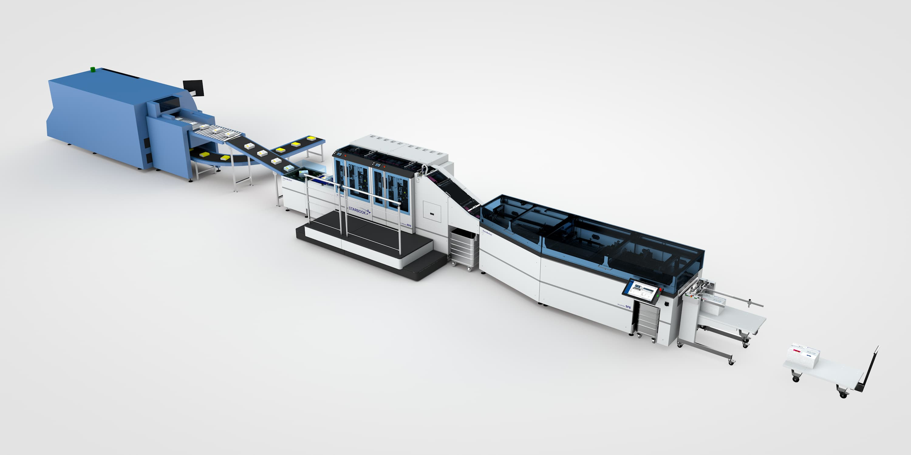
The Hunkeler Starbook Sheetfolder solution will be presented for the first time at drupa. It produces high-quality book blocks fully automatically from the sheet for hardcover and softcover production.

Hunkeler AG
Bahnhofstrasse 31
4806 Wikon
Switzerland

Philipp Fritschi
Head of Communication and Projects

Phone +41 62 745 61 61
Fax +41 62 745 62 60
Email p.fritschi@hunkeler.ch

