Media information

Date 06.02.2023
No. PI 2399
Number of signs 4741
Contact Müller Martini AG
Untere Brühlstrasse 17, CH-4800 Zofingen/Switzerland
Telephone +41 62 745 45 45
info@mullermartini.com, www.mullermartini.com

Müller Martini at drupa 2024

Driving the Digital Transformation

Muller Martini will be presenting four highly automated, industrial production lines that are integrated in the Connex workflow under the motto "Driving the Digital Transformation" at the 1400 m² drupa trade fair stand 1B50 in Düsseldorf from May 28 to June 7, 2024. “We use the latest equipment to demonstrate why we are capable to accompany our customers on their individual journeys into the increasingly digitalized future and how, with our solutions, they can consistently use the potential of new technologies,” says Bruno Müller.

The digital transformation offers new opportunities for both machine manufacturers and customers, according to the CEO of Muller Martini. “The decisive factor is increasingly not the individual machine, but several machines in an integrated production system. This makes the higher-level workflow, which dynamically controls the production process, an important success factor. We are subsequently well prepared to support our customers in digital transformation with our extensive range of solutions which we have expanded in a targeted manner over the years.”

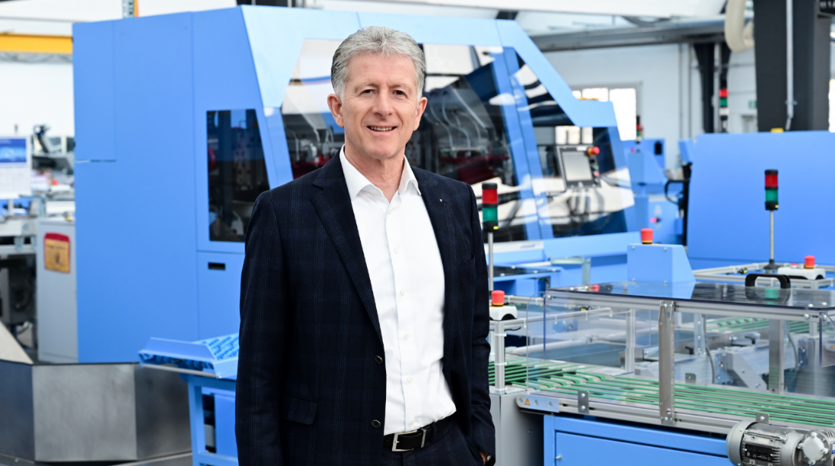
((Photo: Bruno Müller, CEO Müller Martini))
Bruno Müller, CEO Müller Martini AG, is looking forward to drupa 2024: “We accompany the customer as a long-term partner on their journey to digital transformation.”

An end-to-end process is crucial
The opportunities for customers lie in new product forms such as personalized content or the use of high-quality materials - but also in on-demand production, whereby storage costs or overproduction can be eliminated.
The success of a new system depends on the entire process and not primarily on the selected printing technology. Small production volumes are also possible in offset printing. Therefore, the economically viable production of short runs does not necessarily require digital printing presses, but above all an end-to-end process from prepress to dispatch.
Connex: the key to efficient production
The Connex workflow system developed by Muller Martini is a crucial driver behind the digital transformation. "It's really an impressive thing if you consider the necessary functionality to dynamically map without manual intervention all variants and influences in the manufacturing process," emphasizes Bruno Müller.
A typical Connex example is the correct page arrangement - impositioning - on the printing sheet with all the necessary marks, codes and further processing variables that need to be taken into account during further processing for a high-quality product. In extreme cases, these change dynamically from product to product. This is why Connex and its functions are the key to efficient production.
Live demos on four innovative production lines
Müller Martini will be demonstrating how this works in practice at its drupa stand. Integrated in the Connex workflow are all four highly automated, industrial production lines – Antaro Digital perfect binder, SigmaLine Compact, Primera PRO saddle stitcher and Ventura MC 200 thread sewing machine – and on demonstration at the drupa 2024. The world premiere of a Hunkeler solution at the stand also demonstrates that Muller Martini is now an even stronger partner for end-to-end solutions, particularly in the growth segment of short-run book production.
Muller Martini will use live demonstrations of a wide range of different printing products to show how customers will be supported on their individual journeys into the future. "We offer customers a homogeneous system package with our comprehensive, modular platform that can grow with their needs," emphasizes Bruno Müller. "This is how we support them as a partner on their journey to digital transformation. In doing so, we are following our claim: Müller Martini – your strong partner!"
Advisory expertise through practical experience
Muller Martini also attaches great importance to personal discussions with customers besides the live demos in Düsseldorf. Muller Martini advises its customers holistically as a solution provider and shows them ways in which they can strengthen and expand their business with the help of digitalization. "We have acquired a great deal of new knowledge through numerous projects over the past few years. This expertise is becoming more widely available with the significant increase in market activity. Our experts are a decisive factor in planning projects correctly and bringing them to a successful conclusion," emphasizes Bruno Müller.
