Press Release

Date 18.04.2018
No. PI 2141
Number of characters 2647
Contact Muller Martini AG
Untere Brühlstrasse 13, CH-4800 Zofingen/Switzerland
Tel. +41 (0)62 745 45 75, Fax +41 (0)62 751 55 50
info@mullermartini.com, www.mullermartini.com

The only thing missing was our own perfect binder

PieReg Druckcenter Berlin GmbH, located in Germany’s capital city, can now cover its entire softcover value chain in-house with a Pantera from Muller Martini, the first perfect binder in the company’s history.

In-house pre-press with typesetters, typographers, typescript editors and media designers, three sheet-fed offset printing presses with a total of 16 printing units, four folding machines, one saddle stitcher – “the only thing missing was a perfect binder,” says PieReg owner and managing director Sven Regen. This summer, the company. founded in 2004 whose 48 employees work on traditional commercial printing projects, will close this gap with a comprehensive production line from Muller Martini. The production line comprises a 12-station 3692 gathering machine, a Pantera perfect binder with PUR and a Granit three-knife trimmer.

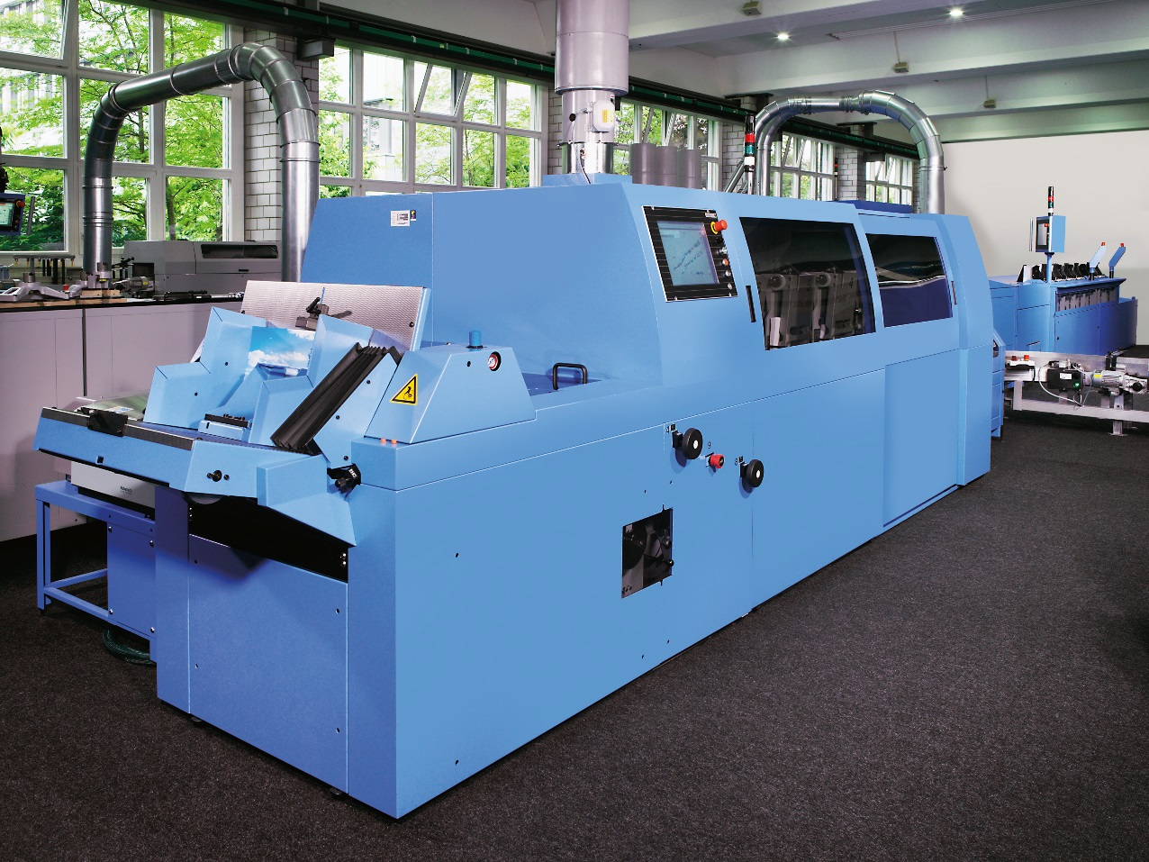
After meeting its saddle stitching needs with a Valore 14 years ago, PieReg Druckcenter Berlin GmbH is now again turning to Muller Martini for its perfect binding needs by installing a Pantera (photo).

To date, PieReg has turned to external partners to bind its softcover products – mainly political brochures, catalogs and manuals with an average print run of 5,000 and a range of 500 to 20,000 copies. According to Sven Regen, there are three primary reasons why the company has switched to in-house perfect binding for the first time in its history. “First, we can produce products more economically because we have the entire value chain installed in-house. Second, we have more time because we no longer need to transport products back and forth between here and the bookbindery. And third, we are better able to control the quality standards of the end product with our own employees.”

Sven Regen and operations manager Sebastian Preissler decided in favor of the Pantera following a thorough evaluation. It is the second machine the company has purchased from Muller Martini, following the Valore saddle stitcher it bought after the company was founded in 2004. The two men visited one of Muller Martini's German customers who had also recently acquired a Pantera for its in-house perfect binding and who was highly satisfied with its new softcover line. What tipped the scales in favor of the Pantera, which is only used at PieReg for offset signatures? “For one thing,” says Sven Regen, “the machine’s construction is robust. That is a very important quality in our printing presses. We were also impressed with Muller Martini’s overall package, including the after-sales service, because a high level of reliability is our top company philosophy.”

