Press Release

Date 19.04.2018
No. PI 2138
Number of characters 2601
Contact Muller Martini AG
Untere Brühlstrasse 13, CH-4800 Zofingen/Switzerland
Tel. +41 (0)62 745 45 75, Fax +41 (0)62 751 55 50
info@mullermartini.com, www.mullermartini.com

“Finishing 4.0 is Our Future”

The Vareo perfect binder and the InfiniTrim three-knife trimmer provide the optimal touchless workflow environment at Printondemand-worldwide.com, prompting Muller Martini to honor the English short-run specialist with the Finishing 4.0 Award.

Printondemand specializes in runs of one copy. Seventy-five percent of the some 8,000 books and magazines that are printed daily by Printondemand in the academic, trade, education, and journal segments using six different paper grades and in color or black/white have a run size of one copy per title. The average run size per job is 1.75 copies, but can be as high as 1,000 copies. “That’s because we produce very efficiently,” explains Andy Cork, the company’s founder and Managing Director. “It’s essential that our production is highly automated. After all, seamless is our business,” he adds.

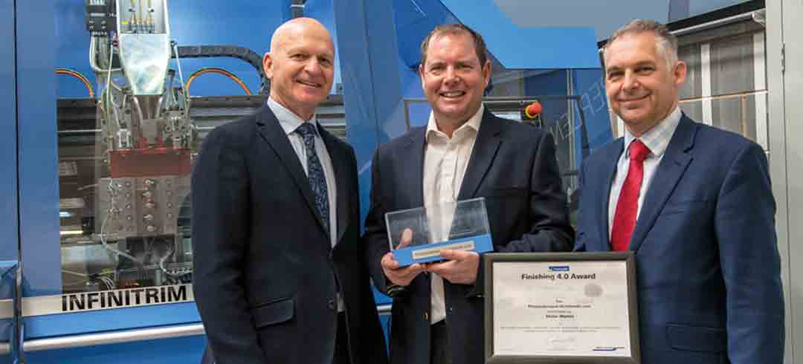
Andy Cork (center), founder and Managing Director of Printondemand, celebrates the Finishing 4.0 Award together with Dirk Deceuninck (left), CEO of Muller Martini Northern Europe, and Ian Clarke, Sales Executive at Muller Martini UK.

Printondemand, which was founded in 1995 and employs 65 people, therefore uses the Vareo/InfiniTrim inline duo for its softcover production. “Finishing 4.0 is our future,” notes Andy Cork. “The fewer manual interventions, the better. That reduces the scope for errors – and error-free production means no production waste. We often used to lose one or two days because of having to reprint copies.”

Andy Cork is particularly impressed by the InfiniTrim three-knife trimmer. “It’s the best machine that I’ve ever bought. Barcode recognition enables automated transfer from the perfect binder to the three-knife trimmer.” Before commissioning the InfiniTrim, three-knife trimming costs at Printondemand were at the same level as for perfect binding. “Today our three-knife trimming costs are just 20 percent of our binding costs,” says Andy Cork. “That’s a major revolution for our market.”

Thanks to the Vareo/InfiniTrim “dream team”, Printondemand, which prints all its products digitally using two inkjet lines, has increased its Overall Equipment Effectiveness (OEE) – which measures success by all factors affecting production (quality, performance, and uptime) – from 48 to 87 percent.“ That’s a very high figure for the graphic arts industry,” notes Andy Cork. “It’s particularly important for us, because printing only accounts for part of our profit margin. What matters to our customers – who don’t have any warehouses according to the principle of ‘think globally, act locally’ and want to order the volume they need at any time for the lowest price – is the whole supply chain.”

Printondemand’s customers increasingly make orders via a portal. The company’s proprietary, web-based Global BookVault software allows Printondemand customers to place on-demand orders online using its print ordering system. Annual growth rates for online orders are over 20 percent. Printondemand dispatches a quarter of all books on the same day that the order is placed.

