Press Release

Date 20.02.2018
No. PI 2126
Number of characters 2279
Contact Muller Martini AG
Untere Brühlstrasse 13, CH-4800 Zofingen/Switzerland
Tel. +41 (0)62 745 45 75, Fax +41 (0)62 751 55 50
info@mullermartini.com, www.mullermartini.com

Equipped for the Insert Boom with the FlexLiner

By investing in a new Muller Martini FlexLiner inserting system, the “Goslarsche Zeitung” newspaper publishing company has equipped itself for handling the increase in its insert volumes.

While the run sizes and number of editions of the Goslar daily newspaper have decreased, the insert market in the German town in Lower Saxony is booming. The newspaper publishing company, which has been run by the Krause family for four generations, has recorded growth of some 40 percent over the last five to six years in the case of the “Goslarsche Zeitung”, which is published three times weekly, and of two advertisement papers. The compact design of the FlexLiner made it the optimal solution for the small production hall to handle the boom in inserts.

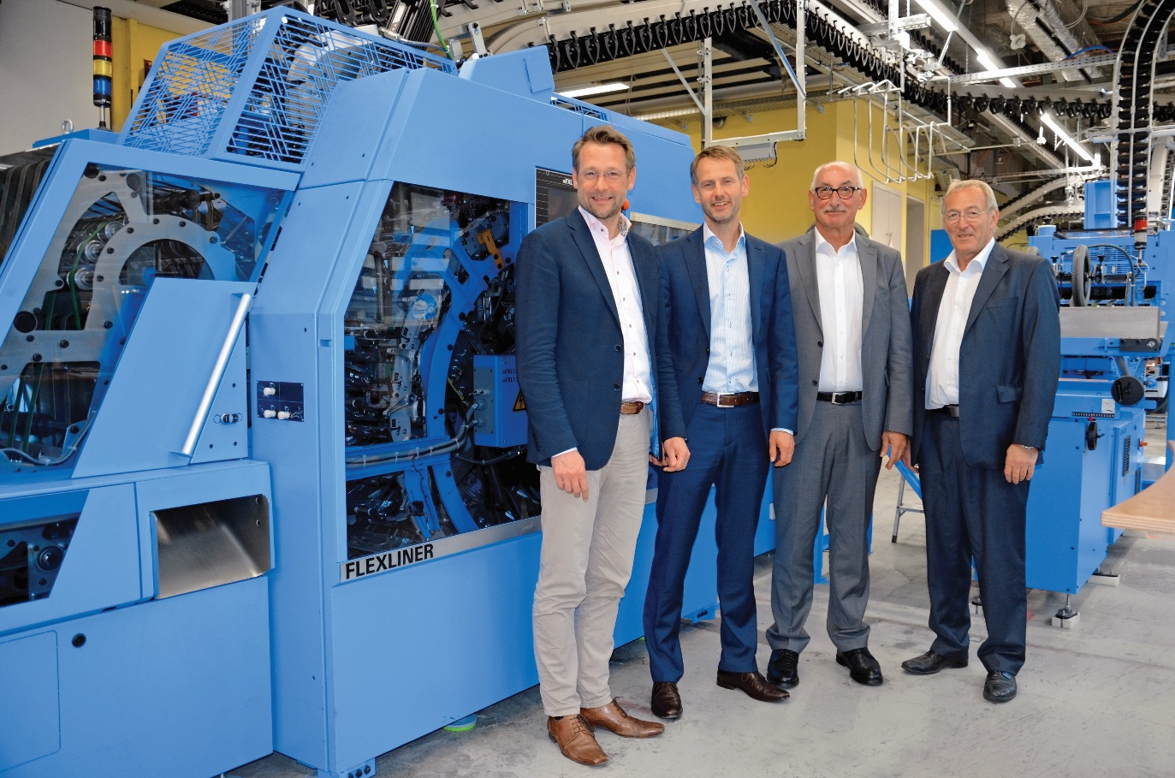
From left to right: Philipp Krause (publisher and Managing Director), Klemens Karl Krause (publisher), Reinhold Achtner (Sales Manager at Muller Martini Germany), Reinhard Krick (engineer and owner of the Krick engineering office)

“It was time to invest in a future-proof inserting system,” say the two publishers, Philipp and Klemens Karl Krause, explaining their main reason for replacing the old BiLiner. The FlexLiner was installed together with a new NewsGrip F newspaper conveyor, two compensating stackers, and a packaging line that had previously been in use at the company. The FlexLiner not only provides a high degree of flexibility in terms of product layout, size, design and loading, but also – thanks to its modular design – has the advantage for the Goslar site that it can be extended to include four more inserting stations if required.

Thorough project planning and effective cooperation made it possible to install the system with only minimal interruption to production. The one-week training course for the machine operators in Switzerland laid the groundwork for smooth commissioning of the machine and reliable production. The staff, who are delighted by the new investment, appreciate the pleasantly quiet and stable running of the machine, as well as its ergonomic design, which makes it comfortable to operate. The publishing company, which employs 115 people, is confident that its market outlook will remain positive, thanks not least to the new investment.

