Media Information

Datum 02.09.2022
Nr. PI 2352
Anzahl Zeichen 2106
Kontakt Müller Martini AG
Untere Brühlstrasse 17, 4800 Zofingen/Schweiz
Telefon +41 62 745 45 45
info@mullermartini.com, www.mullermartini.com

Spectra Print Becomes More Profitable with the Primera PRO

To reduce make-ready times and increase productivity, Spectra Print in Stevens Point, Wisconsin, invested in a new Primera PRO saddle stitcher from Muller Martini – the first North American installation of the Primera PRO.

From 500 to 250,000+ copies – Spectra Print's spectrum of wire-stitched magazines, manuals and calendars ranges from smaller jobs to long runs. The flexibility requirements for the saddle stitchers are correspondingly high. In order to be able to change over even faster, the full-service graphic arts company, which was founded in 1930 and employs 105 people, recently put a new Primera PRO from Muller Martini with cover feeder, six flat pile feeders and Perfetto compensating stacker into operation.

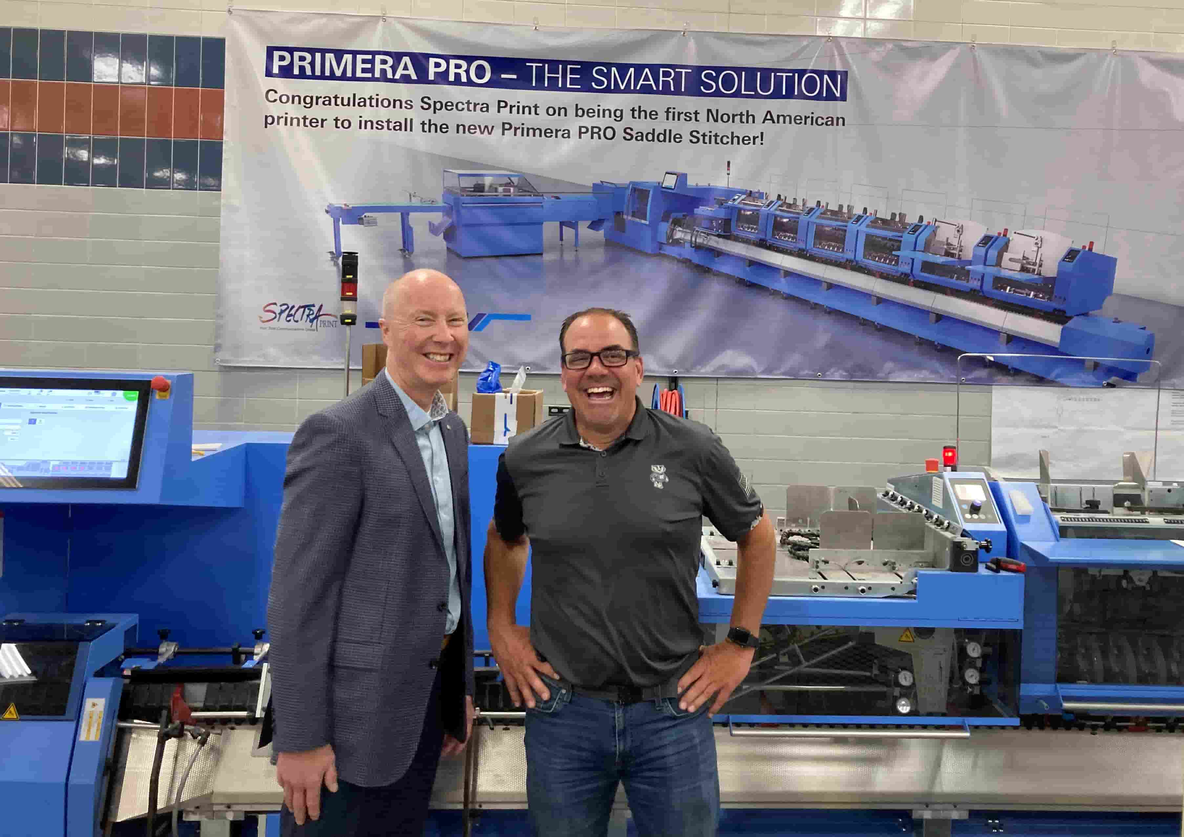
Hans Hofmeister (right), Executive Vice-President of Spectra Print, has a good laugh: "The Primera PRO enables us to acquire more orders." On the left, Eric Olsen, Sales Manager Muller Martini North America.

In keeping with the motto "two make one", it replaces two older models, a 1509 Minute Man from Muller Martini, and one from another manufacturer. The Muller Martini Bravo-M and a Heidelberg ST-90 on the other hand, will continue to run at Spectra Print as backups for the time being.

Executive Vice-President Hans Hofmeister has set himself a clear goal with the commissioning of the Primera PRO: "By cutting make-ready times and increasing production speed, we are reducing our personnel costs and thus becoming more profitable." This in turn improves the traditional company's market position. "By making attractive offers to our customers and offering shorter time windows, we become more competitive and acquire more orders," emphasizes Hans Hofmeister.

Learn more about the Primera PRO saddle stitcher in this blog on the Muller Martini website!

