Press Release

Date 25.04.2019
No. PI 2193
Number of characters 2677
Contact Muller Martini AG
Untere Brühlstrasse 13, CH-4800 Zofingen/Switzerland
Tel. +41 (0)62 745 45 75, Fax +41 (0)62 751 55 50
info@mullermartini.com, www.mullermartini.com

Finishing 4.0 Award for Print Laser Group

Brazil’s Print Laser Group, which is seeing strong growth in the digital printing segment and whose subsidiary Log & Print in Vinhedo produces softcover book blocks with a SigmaLine, was the first graphic arts company in Latin America to win Muller Martini’s Finishing 4.0 award.

Log & Print produces 25 million books annually. Of this amount, 12% are currently printed digitally. The share of books produced digitally has increased by a factor of 24 over the past five years. And it will likely continue to rise significantly. “We expect 60% of our printing volume to be produced on digital printing presses within the next five years,” says General Director Cássio Batista. That’s why the company, which was founded in 1992 and employs 800 people, installed both a new digital printing press and a complete Muller Martini SigmaLine – consisting of a SigmaControl, a SigmaFolder II, a SigmaCollator and a Connex Line Control Pro – last summer.

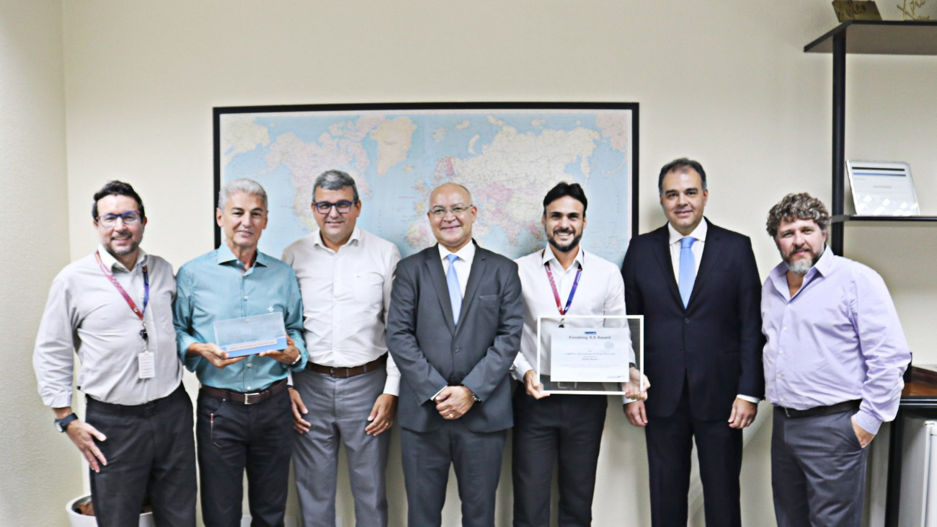
Delighted with the Finishing 4.0 award (from left): Alexandre Batista (Director of HR & Marketing), João Alves (Commercial Director), Mauricio Lamas (Director of Operations), Ronaldo Alves Dias (Sales Manager Muller Martini Brazil), Alderano Fileni (Technology Director), Alexandre Luz (General Director Muller Martini Brazil), Cássio Batista (General Director).

It is used to produce book blocks for (text)books, operating manuals and catalogs, with print runs of between 300 and 10,000 copies – mainly for the Brazilian market, with some orders for Chile as well. “We could do print runs of one,” says Cássio Batista, “but this doesn’t fit to our strategy at present. However, we could see ourselves entering this business segment in the future.” Softcover products are produced at Log & Print – a subsidiary of the Print Laser Group, the largest company in the Brazilian transaction market – on 3 (three) Muller Martini perfect binding systems as well: a Corona, an Acoro and a Tigra.

Muller Martini presented the innovative company with the Finishing 4.0 award for their exemplary workflow. It is the first printing house in Latin America to receive it. “The award is a recognition of our project and confirmation that with our investment we are on the right path for meeting the future challenges facing book publishers,” says Technology Director Alderano Fileni. “It will help us convince customers to make the shift from offset to digital printing.” According to Alderano Fileni, the new SigmaLine has made a significant contribution, in particular reducing the costs for short runs “because the production times for digital book production are much shorter and there are fewer steps.”

