Press Release

Date 08.11.2018
No. PI 2162
Number of characters 2147
Contact Muller Martini AG
Untere Brühlstrasse 13, CH-4800 Zofingen/Switzerland
Tel. +41 (0)62 745 45 75, Fax +41 (0)62 751 55 50
info@mullermartini.com, www.mullermartini.com

FlexLiner Closes Major gap

Thanks to the FlexLiner inserting system, Germany’s well-established Fr. Ant. Niedermayr now carries out inserting in-house, which has given it planning and financial flexibility.

The FlexLiner rounds off the production process for the high-volume printing plant for direct advertising, which has long relied on Muller Martini solutions. It fits in seamlessly with the company’s existing machines, including a sheet-fed offset and four web printing presses. The inserting solution, which is also used for inserts in inserts, enables the company to help its key customer carry out its marketing strategy, which requires three-shift operation with a high level of flexibility and speed. Niedermayr produces up to three million inserts and some 16 million flyers each week for the discount retailer.

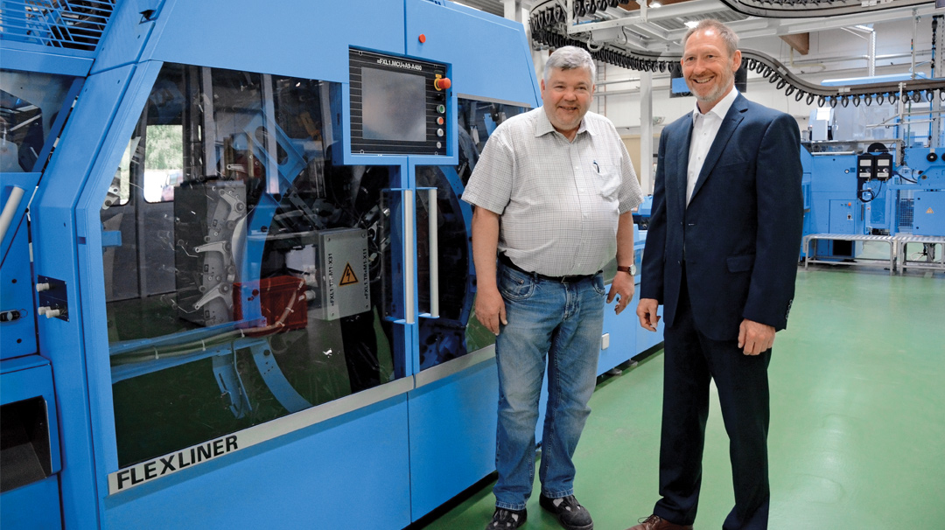
In the “Blue Salon”: Michael Kretschmann (left), Print Finishing Manager at Fr. Ant. Niedermayr, and Frank Skorna, Area Sales Manager at Muller Martini Germany.

Niedermayr uses the FlexLiner to produce products with 8 to 112 pages, and typically operates the machine at the maximum speed of 30,000 cycles per hour. “Sometimes even the Muller Martini engineers are a little amazed by the volumes we handle,” says Michael Kretschmann with a grin. Standing in the hall with the Muller Martini equipment – which is referred to internally as the “Blue Salon” – the Print Finishing Manager, speaks enthusiastically about the systems for saddle stitching and compensating stacking: “The machines do exactly what the manufacturer promises.”

The inserting machine at Niedermayr – which boasts sophisticated mechanics thanks to the Connex data and process management system – has, as an additional option, extended grippers in the conveyor. The fact that employees no longer need to get their hands dirty during changeovers represents major progress. Entering settings is simple and clear thanks to the touchscreen, which makes the FlexLiner a perfect solution for the printing company, as the only constant in its operations is change.

