Media information

Date 21.09.2022
No. PI 2355
Number of characters 3370
Contact Müller Martini AG
Untere Brühlstrasse 17, 4800 Zofingen/Switzerland
Phone +41 62 745 45 45
info@mullermartini.com, www.mullermartini.com

When young employees find the modern operating concept of a saddle stitcher cool

In order to reduce make-ready times, better serve its existing customer base and acquire new orders, Bairle Druck & Medien GmbH in Dischingen in Germany is replacing its two-decade-old Presto saddle stitcher with a Prinova from Muller Martini in coming winter.

At 60 percent, saddle stitching accounts for the largest share of Bairle Druck & Medien GmbH's printed volume – with softcover (Bairle also entered perfect binding eight years ago) and other print products each accounting for 20 percent. The main products are instruction manuals, magazines, periodicals, customer magazines and trade show brochures for industrial companies and publishers. The company, which was founded in 1948 and employs 55 people in two shifts, has been using a Presto saddle stitcher for this purpose for around two decades. This will be replaced next December by a Prinova with cover feeder and seven flat pile feeders.

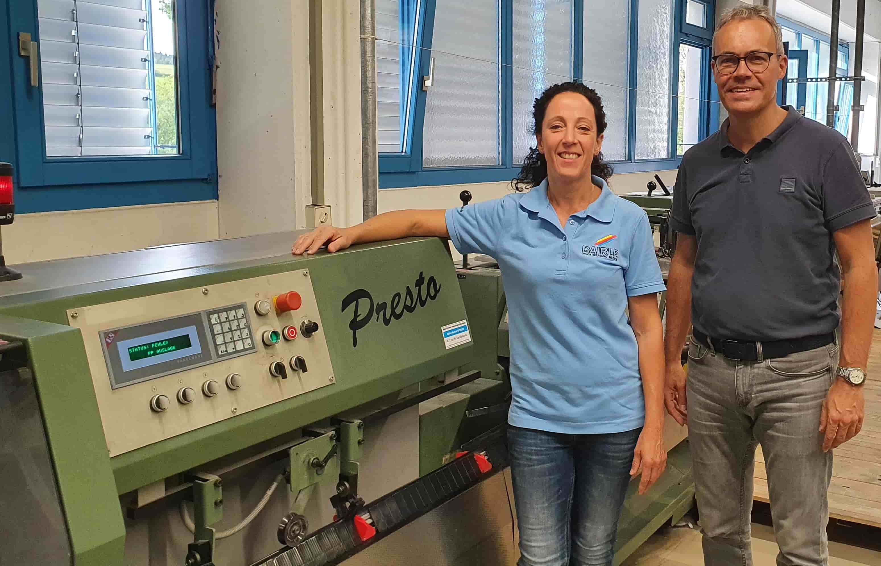
Tobias Bairle (together with bookbinder Corinna List in front of the Presto saddle stitcher, which will soon be replaced by a Prinova): "Modern tools are an important argument for us to find young employees in view of the shortage of skilled workers."

"On the one hand, the Presto is getting a bit long in the tooth," says Tobias Bairle, third-generation managing director of the family-owned company since 2006. "For another, the issue of make-ready times is becoming more and more important." This is of particular importance to Bairle Druck & Medien GmbH because the range of runs produced on the saddle stitcher starts at 1,000 and ends at 50,000, and shorter runs have increased in recent times. It is true that Bairle also produces editions of 1 via its Internet store – from self-publishers, for example. But these very short runs are not produced on the saddle stitcher.

Tobias Bairle chose the Prinova not least because of its modern features. "With the Prinova, Muller Martini, as the world market leader in saddle stitching, has recognized the signs of the times." He is particularly taken with the new operating concept with the large touchscreen. "Our young employees naturally think it's cool when it looks similar to their cell phone on the saddle stitcher and they don't have to make changeovers by hand with a wrench. Such modern tools are also an important argument for us to find young employees in view of the shortage of skilled workers."

Bairle Druck & Medien GmbH is in any case a very IT-savvy company and traditionally open to new technologies. For example, it entered color digital printing back in 2003 and expanded this with five high-performance digital presses in 2015 and a high-speed inkjet press in 2019. Today, digital printing accounts for 50 percent of print volume and will continue to grow in importance at Bairle in the coming years.

According to Tobias Bairle, the good advice and demos from Muller Martini were also decisive factors in his decision to invest in the new saddle stitcher. He first became intensively involved with the Prinova after an online demo offered by Muller Martini to German customers during the Corona pandemic. When the lockdown ended, he traveled to Zofingen, Switzerland. "The Muller Martini presence in the Print Finishing Center impressed me – not only in terms of machinery, but also how the whole workflow is presented."

